Bachelor of Science in Software Engineering
Institute of Information Technology, NSTU


Internship report
based on
Work Experience and Learning
at
Genuity Systems Ltd.

Institute of Information Technology, NSTU
Bachelor of Science in Software Engineering
Course Code: SE 4100
Internship Report
Submitted By
Md Mynuddin
ASH1825007M

Submitted To
Iftekharul Alam Efat
Intern Program Chair
Assistant Professor
Institute of Information Technology, NSTU

Performed at
Genuity Systems Ltd.
Plot-8, Road- 4, Block-A, Section-11, Mirpur, Dhaka- 1216, Bangladesh

Internship Duration: 10 March 2022 - 10 September 2022
Date Of Submission: 23 October 2022

Letter of Transmittal

Iftekharul Alam Efat
Intern Program Chair
Assistant Professor
Institute of Information Technology, NSTU

Subject: Submission of internship report

Dear Sir,
I am glad to present you this internship report based on my experience and learning during my internship program at Genuity Systems Ltd. starting from 10 March 2022 to 10 September 2022. I am pleased to submit my internship report on “Genuity Systems Ltd.” as per your instruction to fulfill the requirement of the SE 4100 course. While preparing this report, I have tried my level best to include all the relevant information, explanations, things I learned from the organization, and my contribution to the organization to make the report informative and comprehensive. It would not have been possible to complete this report without your assistance, for which I am very thankful. Working for six months at “Genuity Systems Ltd.” was amazing and a huge learning opportunity for me. Also, it was a great experience to prepare this report and I will be available for any clarification if required.

Therefore, I pray and hope that you would be kind enough to accept my Internship Report and oblige thereby.

Sincerely yours

--------------------------------------------
Md Mynuddin
ID: ASH1825007M
Institute of Information Technology, NSTU
Email: mynuddin2513@student.nstu.edu.bd

Letter of Endorsement
To Whom It May Concern

Subject: Approval of the Report

This report will be submitted to the intern and placement office of the Institute of Information Technology, Noakhali Science and Technology University as a part of the internship program and will be presented to the internship committee for evaluation.

This report only contains information on my work in different fields at Genuity Systems Ltd. as an intern.

All information in this report is true and has not yet been published.

Internship Supervisor  ---------------------------------- | Trainee  ----------------------------------
Nafees Mahbub  Software Engineer  Genuity Systems Ltd. | Md Mynuddin  ID: ASH1825007M  Institute of Information Technology, NSTU

Acknowledgment

I would like to express my deepest gratitude to Iftekharul Alam Efat, Assistant Professor, Intern Program Chair, Institute of Information Technology, Noakhali Science and Technology University for his kind support and inspiration which has immensely strengthened my confidence during my internship program.

I owe my profound sense of gratitude to Nafees Mahbub, Software Engineer, Genuity Systems Ltd. for his kind help and cooperation during my stay at Genuity Systems Ltd. He himself managed all the things that I asked for and always provided the solutions to the problem that I faced during the completion of my projects. Without his advice, I might have sprawled and the projects might have ended in failure.

I am also very much grateful to my team members Emrul Hasan Zawad and Rifat Hasan for their great support of the project respectively. Their guidance has led me this far which I can never forget.

Executive Summary

This report is a detailed overview of my internship journey at Genuity Systems Ltd. During my Internship, I have learned a lot about Communication with Team Members, Machine Learning, Neural Networks, Deep Learning, Computer Vision, and its different applications. I have known about the workflow of the company along with the functions the Software department performs. I have learned to work in a corporate space which not only enriched me professionally but also helped me grow personally as well. My contribution was appreciated by my supervisor and other members of the department. The career path I would be selecting for myself is quite influenced by my internship as I have had a great opportunity to practically see how to solve real-life problems. However, this report has been written in a short time. I have tried my level best to make it meaningful by reflecting on my work at Genuity Systems Ltd. Also, I have summarized my overall experience, with my learning and challenges faced as an intern.

Table of Contents
-------------------------------------------------------
Letter of Transmittal
Letter of indorsement
Acknowledgement
Executive Summary
List of Figure
Chapter 1: Introduction 8
1.1. Introduction 9
1.2. Objective 10
1.3. Methodology 10
1.4. Scope 11
Chapter 2: Company Profile 12
2.1. Company Name 12
2.2. Registered Addressed 12
2.3. Company Overview 13
2.4. Mission and Vision 13
2.5. Valued Clients 14
2.6. Products 15
2.6.1. gPlex Smart IVR 15
2.6.1.1 gPlex® - Smart IVR Features 16
2.6.2. Call Blaster 17
2.6.2.1 Reach Millions in Hours 18
2.6.2.2 Benefits of gPlex® Call Blaster 18
2.6.2.3. How gPlex Call Blaster do for your Business promotion? 19
2.6.3. Mobile Banking Apps 20
2.6.3.1. gPlex® Mobile Banking App Features 20
2.6.4. Advanced IT Training 21
2.6.4.1. Go to a Professional be a Professional! 21
2.7. Solution 22
2.7.1. Contact center solution 22
2.7.1.1. gPlex® - Enhancing Customer Experience! 22
2.7.1.2. gPlex® Contact Center Feature 23
2.7.2. Smart PBX Solution 23
2.7.2.1. Smart Business Phone Solution 23
2.7.3. Mobile Application 24
2.7.3.1. Types of Application: 25
2.8. BPO Services 25
2.8.1. Call Center Services 25
2.8.1.1. Contact Center Service 26
2.8.2. Why Choose Genuity BPO as Call Center Outsourcing Services Partner? 26
2.9. Company Hierarchy 28
2.10. Office Culture and Environment 28
2.10.1. Overview 28
2.10.2. Friendly Working Environment 28
2.11.3. People 29
2.11.4. Beware of the Meeting 29
2.11.5. Self Responsibility 29
2.11.6 Keep the workplace Comfortable 29
2.11.7. Being Humble 30
2.11.8. An honest approach to business and trust in each other 30
2.11.9. Dress Code 30
2.11.10. Special Day Celebration 30
2.11. Office Schedule 42
2.12. Facilities for Employees 42
2.12.1. Domestic Environment 42
2.12.2. Lunch and snacks 43
2.12.3. Comfortable Sitting Arrangement 43
2.12.4 Dinning and Prayer Room 43
2.12.5. Games 43
Chapter 3: Internship Details 44
3.1 Joining Letter 45
3.2. Assigned Team 49
3.3. First day at office 49
3.4. Technical Skill I learn 50
3.4.1. Python 50
3.4.2. Statistics 51
3.4.3. Data Visualization 52
3.4.4 Machine Learning 52
3.4.4.1 Data Preprocessing 52
3.4.4.2 Supervised Machine learning 52
3.4.4.3 Unsupervised Machine Learning 53
3.4.5. Audio signal processing for machine learning 57
3.4.6. Bash Script 57
3.4.7. Neural Networks 58
3.4.8. OpenCV 59
3.5. Assigned Project 61
3.5.1 Face Recognition 61
3.5.1.1 Project Screen Shoot 61
3.5.1.2 Tools and Technology I used 63
Chapter 4: Self Assessment 65
4.1. Punctuality 65
4.2. Attitude 66
4.3. Ability to learn 66
4.4. Dependability 66
4.5. Initiative 67
4.6. Quality of Work 67
4.7. Relations with Others 67
4.8. Maturity-poise 68
4.9. Judgment 68
4.10. Initiative 68
4.11. Teamwork 69
4.12. Overall Progress 69
Chapter 5: Conclusion 71
Chapter 6: References 72

List of Figures
Figure 1: Valued Clients ------------------------------------------------------------------------------------ 14
Figure 2: gPlex® - Smart IVR ----------------------------------------------------------------------------- 15
Figure 3: Call Blaster ---------------------------------------------------------------------------------------- 16
Figure 4: gPlex® Call Blaster Solution ------------------------------------------------------------------ 17
Figure 5: Mobile Banking Apps----------------------------------------------------------------------------- 19
Figure 6: Genuity Training------------------------------------------------------------------------------------ 21
Figure 7: Contact Center Solution-------------------------------------------------------------------------- 22
Figure 8: Smart Business Phone Solution---------------------------------------------------------------- 24
Figure 9: Call Center Services ------------------------------------------------------------------------------ 25
Figure 10: Company Hierarchy------------------------------------------------------------------------------ 28
Figure 11: Birthday Celebration of Abdullah Vai (Middle)--------------------------------------------- 31
Figure 12: Eid celebration------------------------------------------------------------------------------------- 32
Figure 13: Genuity 19th anniversary celebration------------------------------------------------------- 33
Figure 14: Farewell of an employee----------------------------------------------------------------------- 34
Figure 15: Pohela Boishakh Celebration ----------------------------------------------------------------- 35

Figure 16: Blessing us to be married in pohela boishakh celebration ----------------------------- 36
Figure 17: Food provided from the office in Pohela Boishakh Celebration ---------------------- 37
Figure 18: Machine Learning Team in Pohela Boishakh---------------------------------------------- 38
Figure 19: Iftar Party------------------------------------------------------------------------------------------- 39
Figure 20: Journey Begins with IFIC Bank--------------------------------------------------------------- 40
Figure 21: Table Tennis Championship------------------------------------------------------------------- 41
Figure 22: Annual Picnic------------------------------------------------------------------------------------- 42
Figure 23,24,25: Joining Letter---------------------------------------------------------------------------- 45
Figure 26: Office camera for face recognition---------------------------------------------------------- 60
Figure 27: Face recognition for single face------------------------------------------------------------- 61
Figure 28: Face recognition for multi-face-------------------------------------------------------------- 61

Chapter 1: Introduction

1.1. Introduction
An internship is “any official or formal program to provide practical experience for beginners in an occupation or profession.” The most important element of internships is integrating classroom knowledge and theory with practical application and skills. It's an opportunity for students to work at an IT firm for a fixed, limited period to exercise their knowledge and get acquainted with industry practices. It offers students a period of practical experience in the industry relating to their field of study. Experience gained through this internship program is valuable as it allows students to experience how their studies are applied in the real world, and as work experience, it can be highly attractive to potential employers on a candidate’s CV. The internship provides students the opportunity to test their interest in a particular career before permanent commitments are made.

As a student of the Institute of Information Technology (IIT) of Noakhali Science and Technology University, I was very lucky to have a whole semester for doing my internship and I had the opportunity for gaining industrial experience. I was sent to Genuity Systems Ltd. to complete my internship. I joined Genuity Systems Ltd. as an intern on 10 march 2022. Actually, I love to write code in python and I chose the Data Science field. So, I wanted to complete my internship in this field to test real-world problems. And in the 7th semester, IIT offers a glorious opportunity to their students of having an internship within their bachelor program and I got the chance.

As expected, I was assigned to the “Machine Learning Team” software department of Genuity Systems ltd. Dhaka Office. The expectations were high and now almost nearing the end of my internship I must admit that it was a really wonderful experience. There were many obstacles, and new technologies that I had to handle, so the journey wasn’t simple. But after overcoming each challenge I discovered a new potential within myself. The skills that I have gathered are priceless to me. Moreover, after completing my internship program, now I am quite confident that I will establish my career as a Machine learning Engineer in the future.

1.2. Objective
The main goal of the internship is to develop a profound grasp of professional interactions, engage in activities, and interact with others in the workplace. This report's main goal is to give a general overview of Genuity Systems Ltd.'s internship program.This is a short description of my six-month internship as a compulsory component of the BSSE program. At the beginning of the internship I formulated several learning goals, which I wanted to achieve:
- Gain experience
- Identify career goals
- Strengthen a resume
- Attain BSSE program credits
- Experience different work environments
- Develop new skill
- Job opportunities
- Networking
- Observe and learn ethics at work
- Leadership
- Taste the real-world problem to solve

1.3. Methodology
The overall report was created by examining my time spent working as an intern at Genuity Systems Ltd. The data used in this research was gathered from both primary and secondary sources.

- Primary Data
- Direct inspection through the internship time
- Conversation with employees
- Team meeting

- Secondary Data
- Genuity Systems Ltd. website
- Genuity Systems Ltd. Linkedin profile
- Internet

1.4. Scope
Every student needs internship experience to put their classroom learning into practice and gain real-world experience from any organization. This internship experience will be useful for my future career. This report was created only for academic purposes and satisfies the internship affiliation requirement. Here, I go into more detail about my entire experience from the Genuity Systems Ltd. internship program. I made an effort to outline Genuity Systems Ltd.'s corporate structure and services. This study also includes information on the structure of team management and the method of working in a team. It also discusses how I adjust to the workplace. It primarily focuses on the actual projects I worked on and the many tools and technologies I employed. The mission and vision of Genuity Systems Ltd., management, partners, clients, company culture, technology, development methodology, my role and actions with the team, etc. were also shown and documented. I worked on this report with Mr. Iftekharul Alam Efat, an assistant professor at IIT, NSTU, as my supervisor.

Chapter 2: Company Profile

2.1. Company Name
Genuity Systems Ltd.

2.2. Registered Addressed
- Dallas, Texas Office
17106 Preston Bend Dr, Dallas
Texas, 75248, United States
(972) 248-2766
- Dhaka, Dhaka Office
Genuisys Point, Plot-8, Road -4, Block-A
Section - 11, Mirpur
Dhaka - 1216, Bangladesh
info@geuitysystems.com
sales@geuitysystems.com

2.3. Company Overview
Genuity Systems Ltd. is an IT company established in the year 2003 in Dhaka, Bangladesh. It has by now established itself as one of the prestigious entities providing IT and telecommunications-related services not only in Bangladesh but also in overseas countries.

The services offered by Genuity range from Contact Center solutions to VoIP soft-switch and billing solutions (for international markets), Mobile Dialer solutions to IVR and IP-PBX solutions, as well as professional IT training. We have established a sizable clientele both domestically and abroad in a short period of time. This was made possible by the quick turnaround and unwavering quality and dependability of our services, which are due to our highly qualified, competent, and motivated personnel. Before beginning a one-on-one relationship with a customer, we make an effort to get to know them and comprehend their needs. We often take on difficult projects, work on them with a lot of love as if they were works of art, and deliver the finished product to the delight of our esteemed clientele.

2.4. Mission and Vision
The goal of Genuity Systems is to offer the local community the most cutting-edge, comprehensive, and innovative communications, information technology, and software system solutions through a highly motivated, innovative, skilled, and experienced team of professionals, thereby enhancing the success of Genuity and the satisfaction of the markets and clients we serve.
Genuity's vision is to promote our products worldwide. Offers high-quality service to customers.

2.5. Valued Clients
 |  |  | 
 |  |  | 
 |  |  | 
 |  |  | 
 |  |  | 
 |  |  | 
 |  |  | 
 |  |  | 

Figure 1: Veiled Clients

2.6. Products

2.6.1. gPlex Smart IVR
gPlex® Smart IVR allows users to enjoy quick, instantaneous service from the IVR. Unlike the traditional IVR, customers do not need to wait, listen to the entire IVR, or remember which IVR node is what. gPlex® Smart IVR is an internet-enabled service that does not require the customer to install any apps as long as the phone is equipped with internet capability with HTML5 compatible browser. Besides, its audio and visual representation enables customers to get quick service on the go and saves customers huge costs from the traditional IVR

Customer will call the call center (short code) and select Smart IVR service through DTMF. The call will be then disconnected and an SMS will be sent to the customer with a one-time link, upon clicking on that link customer will be able to use gPlex® Smart IVR service.

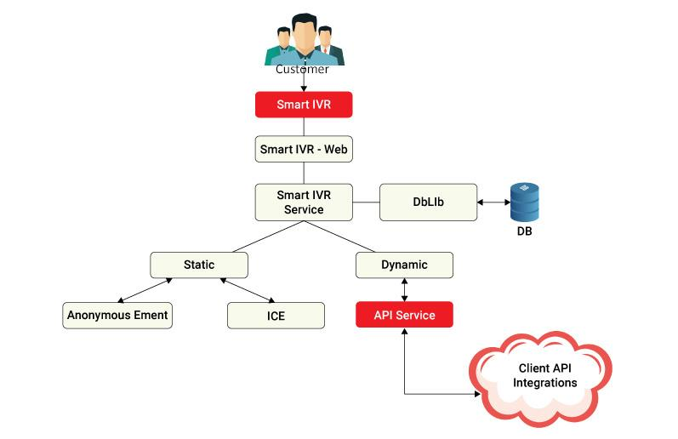
gPlex® Smart IVR request will come from smartphone into Smart IVR web. SIVR service will get the information from the database through DbLIb, play the static announcement and get Instant Customer Endorsement (ICE), as well as pull the account-related service or any other information via API from the City bank ecosystem to provide the dynamic service to the customers.

Figure 2: gPlex® - Smart IVR

2.6.1.1 gPlex® - Smart IVR Features
- Customer no need to remember the DTMF for the corresponding service node.
- gPlex SMART IVR is both compatible with smartphones and tablets as long the phone is capable of internet connectivity.
- Customer does not require to install any apps to enjoy the gPlex SMART IVR service.
- gPlex SMART IVR service is created with the concept of responsive design, which means that based on the customer's smartphone/tablet screen size all the menus will be aligned according to the screen aspect ratio.
- Customer can easily view or get service from gPlex SMART IVR through backend integration with the client ecosystem via API.
- In gPlex SMART IVR with the help of a news bulletin feature company management can broadcast short messages to all live customers who are using SMART IVR services.

- gPlex SMART IVR also support small forms where customer can directly submit forms to the company. E.g. For internet banking service customers will no longer need to go to the bank, rather through gPlex SMART IVR can submit the form directly to the bank.
- gPlex SMART IVR also can also be integrated with the gPlex OTP module for additional security during financial transactions.
- Seamless integration with existing IVR.
- Better routing, fewer zero-outs, and fewer calls.
- gPlex SMART IVR has both audio and visual representation of the IVR nodes, along with backward and forward of the IVR nodes and an option to enable or disable sound.
- Management can enjoy rich reporting of customer interaction. For example Service Report, Service Summary, Interactive Customer Endorsement Report, SMART IVR Menu & Service Hit Count.
- Since, gPlex SMART IVR is an internet-driven service gPlex recommends deploying the solution under the DMZ zone.
- Most user-friendly experience compared with the traditional IVR.

2.6.2. Call Blaster

Figure 3: Call Blaster
gPlex® Call Blaster is a highly scalable automatic over-the-phone message broadcasting system. It can dial millions of numbers in a matter of hours. It can manage multiple campaigns simultaneously. Its management tool allows the setting of media changes, minimum and maximum ports, control of Calls per Second (CPS), and much more. The system comes with a real-time dashboard and rich reporting features including the provision of customized reports. The gPlex® Call Blaster is an independent system that can be deployed either as a stand-alone system or as part of a ‘Contact Center System’.

2.6.2.1 Reach Millions in Hours
With the help of the gPlex® Call Blaster system, firms may communicate with numerous contacts at once to convey pertinent information while operating under a single campaign. An application program interface (API) that is incorporated into the backend ecosystem can be used to deploy a built-in interactive voice record (IVR) system to collect customer feedback or carry out commercial operations. We work hard to give our business clients high-quality service encounters so they can pass those along to their clients.
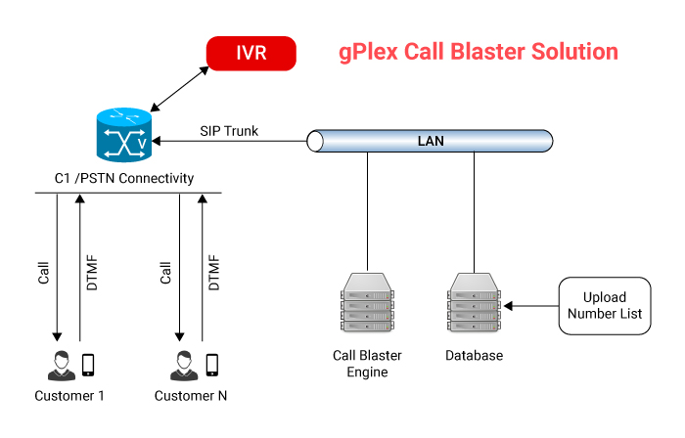

Figure 4: gPlex® Call Blaster Solution

2.6.2.2 Benefits of gPlex® Call Blaster
- Reach millions of customers in hours.
- Run several campaigns simultaneously.
- Real time dashboard for call statistics and sales count.
- Built-in IVR to obtain customer feedback.
- Can perform business processes through API integration.
- API-Interface to pull contact information from third-party CRM.
- Can upload millions of contact information in Excel, CSV, text format, etc.
- Automatic Language selection.
- Support STM-1/E1/SIP trunking.
- Stand-alone solution scalable to 2000 ports/channels per campaign.
- Zero capex and low opex.
- Service available through hosted platforms under the pay-as-you-go model.

2.6.2.3. How gPlex Call Blaster do for your Business promotion?
With gPlex® Call Blaster, you can call millions of customers with a customized voice message for getting feedback, promote your new product or service, inform them about your upcoming event, and much more! It's a web-based automatic outbound dialing solution that scrolls through your existing phone contacts and sends out your pre-recorded message. Whether it's updating your target group on the latest special offer or letting them know about a new product, gPlex® Call Blaster services can help you do it faster and more comprehensively than ever before.
Special Promotion:
Businesses often introduce time sensitive special promotional offers. The challenge is such offers must be communicated to a very large number of target customers within a short time window, say reaching out to millions within a couple of days. Creative call campaigns executed by gPlex® Call Blaster service may be the ideal solution to handle such situations efficiently. Integrated APIs may be deployed to automatically subscribe and deliver certain service products to previously registered customers. Examples of use: (i) Travel Agents promoting special occasion/event price discounts, (ii) Home improvement companies offering special discounts on specific items like flooring/carpeting for a limited period.

Customer Feedback:
As a customer satisfaction exercise businesses often need to obtain customer feedback following the delivery of their services. gPlex® Call Bluster service may be used to have those customers automatically called during a user-defined time window to obtain customer feedback on services they received. Example of use: (i) Car/AC/Heater repair shops seeking feedback from their customers who visited them recently.

Emergency Messaging:
Cities, Schools, and Businesses often need to send out emergency messages to their constituents/customers within a very short window. gPlex® Call Bluster service can offer a very effective and appropriate solution to handle such situations. Example of use: (i) School districts sending out school closure notice to all students/staff due to impending snow storm, (ii) Cities sending our flash flood warning-related calls to their citizens.

2.6.3. Mobile Banking Apps

Mobile Banking is a service provided by a bank or other financial institution that allows its customers to conduct financial transactions remotely using a mobile device such as a smartphone or tablet. gPlex® mobile apps come in handy for enterprise customers and allow access to customized services.



Figure 5: Mobile Banking Apps

2.6.3.1. gPlex® Mobile Banking App Features

Check the balance of your accounts | Mobile Top-up | View Summary of Credit Cards
View past transactions | Change TPIN (Banking PIN) | Pay your credit card and bill
Account overview | Email to Customer Contact Centre | View past billed statements
Transfer funds | Call to Customer Contact Centre | View unbilled transaction
Fund Transfer between own accounts | Set profile picture to personalize app | Balance transfer
Request for account statement | Frequently asked questions (FQAs) | Apply for a loan on credit
Schedule Fund Transfer | Locate nearby branches and ATMs | Report Lost / Damaged Card
View Scheduled Payments | Locate discount partners outlets | Regenerate Credit Card PIN
Bill / Utility Pay | Message/News board | E-statement of your Credit Card

2.6.4. Advanced IT Training

2.6.4.1. Go to a Professional be a Professional!
Genuity Training is a technical career house providing hands-on, intensive training to develop the technical skills they need for a successful career as an Information Technology (IT) Professional. Genuity Training offers a broad range of IT training courses and programs which ensures a very specific training package for all skilled IT Professionals.
Why Genuity Training
- Expert trainers
- Various programming courses
- A well-furnished and attractive labs
- Committed to providing quality services

Genuity takes great care in selecting highly experienced professional instructors, cross-trained in several technologies. They can relate the strengths and weaknesses of the products and present alternative solution strategies when they are warranted.

For details about Genuity Training, please visit www.genuitytraining.com

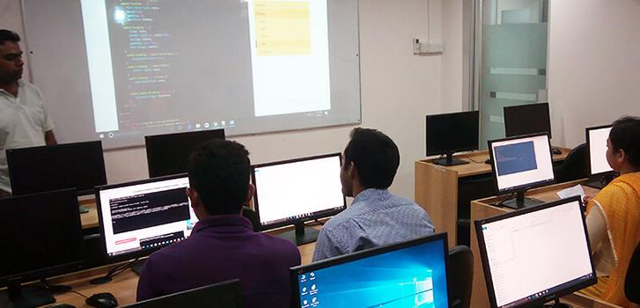
Figure 6: Genuity Training

2.7. Solution

2.7.1. Contact center solution


Figure 7: Contact Center Solution

2.7.1.1. gPlex® - Enhancing Customer Experience!

The gPlex® Contact Center solution is likely the most feature-rich, cost-effective, simple to setup, dependable, and highly scalable system, regardless of whether you need a cloud-based or on-premises contact center solution. No issue if you want your agents spread out geographically. The gPlex® Dashboard enables real-time, glance-based monitoring of contact center activity. Increased productivity and customer satisfaction are facilitated by swift realization. The gPlex® contact center solution generates various, highly useful reports and charts that help your contact center run smoothly. The gPlex® contact center solution is scalable and simple to deploy. While the core server is located at the central office, agents can be put remotely at various places.

2.7.1.2. gPlex® Contact Center Feature

Multi-channel ACD | API for Telebanking | PCI-DSS compliant
Flexible IVR | Voice logger | Webchat
Smart IVR ( Visual IVR ) | Screen logger | Chatbot
Blaster IVR / Agentless IVR | Find last Agent | MoH with Filler
Multi-location call route | Dashboard | Social Media integration
Caller priority | Wallboard | SMS/TEXT integration
Screen popup | Predictive dialler | Email and Ticketing
Integrated CRM | Unified agent desktop | TTS, STT, ASR
Mobile App for Supervisor | Unified Reporting | Work Force Management

gPlex® Contact Center Solution is suitable for any size of contact center business. Efficient agent desktop softphone and one-touch keyboard functionality facilitate easy navigation and increased performance. It will improve efficiency through reduced manpower costs and increases overall profitability.
For more details about gPlex® Contact Center solution please visit www.gplex.com

2.7.2. Smart PBX Solution

2.7.2.1. Smart Business Phone Solution
gTalk® PBX provides a complete suite of business communications services suiting individual business needs at affordable costs. gTalk® PBX features include auto-attendant, call queue, conference calling, do-not-disturb, and much more. It offers companies with multiple locations the ability to operate under one umbrella, allowing increased productivity and reduced resource requirements. Now your employees can work from home, or any location globally with our easy-to-use, plug-and-play gTalk® PBX solution.
Auto Attendant | Web-based portal | Call park
Music on hold | Call forwarding | Call monitoring
Called ID & name | Call return | Ring Groups
Call waiting | Mobile App | IVR
Call Hold | The Last number redial | Voice mail
Call transfer | Do not disturb ( DND) | BLF (Busy Lamp Field )
Call pick-up | Find me/Fellow me | Page / Announcement (PA)
Personalized greetings | 3-way conference | Conference-Bridge
Missed call indicator | Speed dial | Voice Recording
Call history | Simultaneous ring | Advance call routing

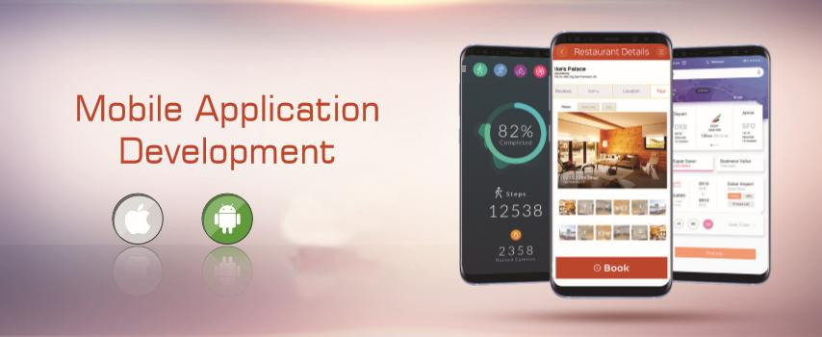
gTalk® PBX service is flexible enough to connect multi-location businesses under a single PBX platform, scale up and add users instantly. The solution is highly scalable. You can increase or add extension/capacity as your business grows without having to worry installation of new equipment.

2.7.3. Mobile Application

Figure 8: Smart Business Phone Solution

INNOVATIVE CUSTOM MOBILE APPLICATION DEVELOPMENT
Our vision to is help businesses in enhancing and project their image and boost performance through the development and maintenance of innovative aesthetically designed and user-friendly Smart Mobile apps.

2.7.3.1. Types of Application:
- Business apps
- Finance and Banking apps
- Health care apps
- E-commerce apps
- Telecom apps
- News & Magazines apps
- Voice related apps
- Entertainment apps

2.8. BPO Services

2.8.1. Call Center Services
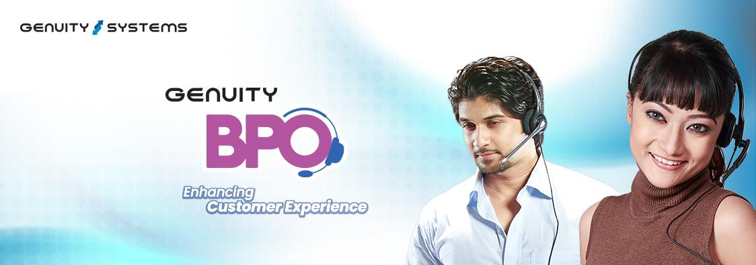
Figure 9: Call Center Services
Genuity BPO offers best-in-class call center services, both inbound & outbound, to clients from different industries such as banking and financial, healthcare, insurance, manufacturing, travel and hospitality, automotive, energy utilities, logistics, retail and consumer, telecommunication, and others. We provide 24 X 7 call center solutions to stay connected with your clients and customers to provide business solutions around the clock.

We provide affordable but quality and technologically powered (gPlex) call center services to startups, and medium and large size companies. We are one of the trusted enterprise call center solution providers in Bangladesh and USA Service industry with advanced technology like Self-Service, Mobile Dashboard, Multilevel IVR, Smart IVR (VIVR), Phonetic Recognition, CIVR, Intelligent Routing, etc. Our skilled and dedicated professionals provide exceptional information or technical support service to customers.

2.8.1.1. Contact Center Service
- Inbound Call Center
- Outbound Call Center
- Tele Marketing/ Tele Sales
- Chat Support Services
- Email Support Services
- Customer Care Services

2.8.2. Why Choose Genuity BPO as Call Center Outsourcing Services Partner?

Assure High Quality of Services
Genuity BPO promises to adhere to the highest standards of quality services. Our quality assurance team keenly observes & regulates that all the call center operations are performed up to the specified standards. Our industry experts are on hand to ensure the deliverables.
Enhanced Customer Satisfaction
Being a leading call center solution provider, we offer a variety of customer engagement channels to be outsourced such as phone, email, live chat, social media, etc. to allow you to reach an extensive section of customers quickly that in turn, resulting in increased customer satisfaction & retention.

Make Use of Analysis
Our all-inclusive Analytics provide crucial insights related to the performance of your brand & its market value which facilitates a complete understanding of the product, to the consumer.

Right analytics and data help in more profitability and enhance customer service. Work with Best-in-Class Technology
Our entire contact center outsourcing services are performed through the latest technologies, which can be successfully incorporated with Customer Relationship Management tools with advanced technology like Self-Service, Mobile Dashboard, Multilevel IVR, Smart IVR, Phonetic Recognition, etc. Our outsourced call center solutions help businesses provide technology-enabled global call center services.

Regular Training to the Team
In order to maintain the perfect communication skills & make the employees keep updated about the industry knowledge, we provide regular training & development of our call center outsourcing services staff.

Email Response & Help Desk
We are a global call center services provider & ensure that our customers get incessant support. We provide a pertinent & constant customer service experience with a single point of contact & instantly respond to customer questions during the sales process.

2.9. Company Hierarchy
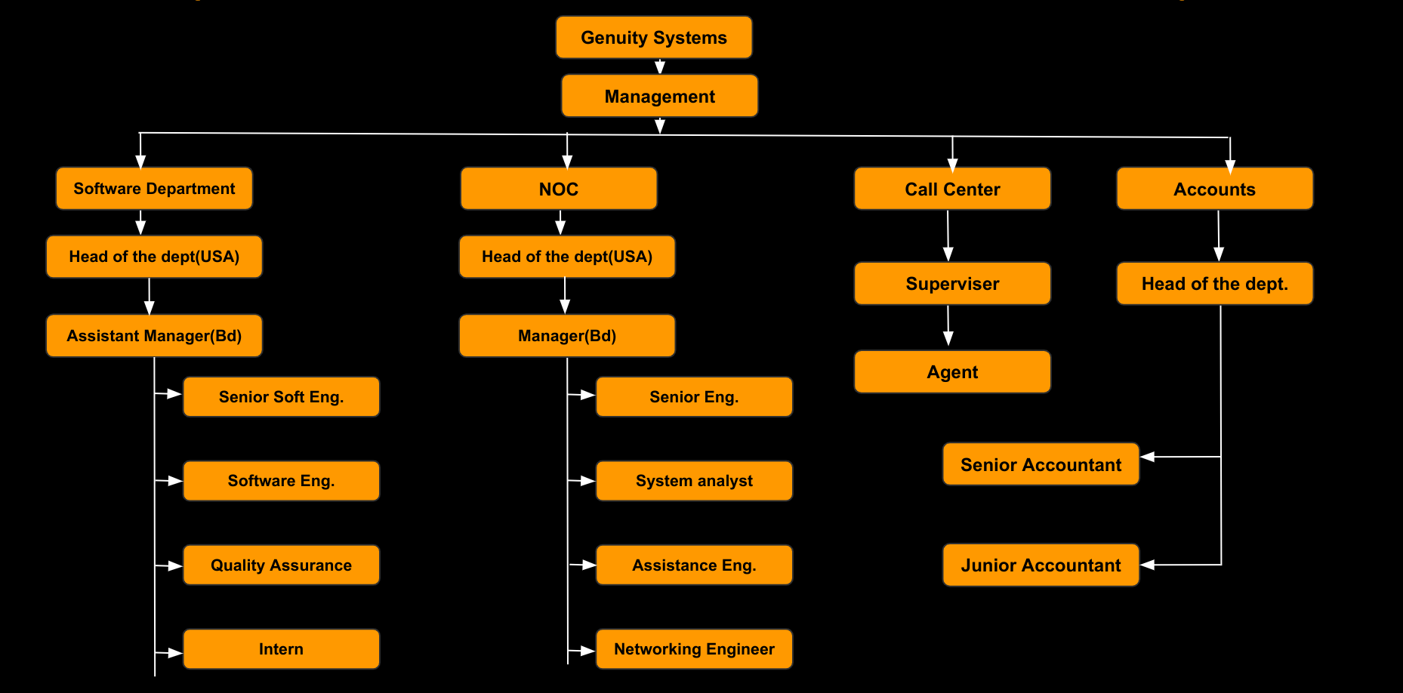
Figure 10: Company Hierarchy

2.10. Office Culture and Environment

2.10.1. Overview
Manpower is one of the most important resources of any organization. The performance and success of an organization depend on the employee of the company. Therefore providing a healthy and friendly environment in addition to a professional setup is very important. Genuity believes that in the journey employee should stay fit both physically and mentally while absolutely loving what they do. Hence, Genuity provides all the facilities that are needed for the refreshment of employees while doing their creative jobs.

2.10.2. Friendly Working Environment
Genuity has a great working environment in the office space, totally custom designed for a software development company. From color selection to furniture orientation it has been very careful to create an environment that actively enhances the knowledge exchange and collaborative nature of work.
I have spent 6 months as an intern at Genuity. All the members did not differentiate us from other employees. All the members are very friendly. They help us to adapt to new changes and challenges. And this friendly environment helps us to refresh our minds while working for hours.

2.11.3. People
Genuity doesn't hire developers, designers, or QA engineers, it hires people who can solve problems. And it hires only the best. It runs regular training and review sessions to keep employees on top. And its culture of constructive criticism, learning, and sharing expands our horizons and keeps employees level-headed.

2.11.4. Beware of the Meeting
Awareness about the meeting has become a habit of the employees of Genuity Systems Ltd. Because they believe that a meeting is the only arsenal that can draw attention as well as helps to communicate project progress, clarifies product direction, and identifies any issues or impediments. Although not everyone speaks at these meetings, every team member is present in the meeting. Besides this, a meeting is essential to make sure that the project is almost always moving forward. Being present every day keeps everyone accountable and prepared for that day. It allows for the project's focus to be better dictated.

2.11.5. Self Responsibility
The meaning of responsibility is "response-ability" - the ability to choose one response. Genuity employees are highly proactive people who recognize their responsibility. They do not blame circumstances, conditions, or conditioning for their behavior. Their behavior is a product of their own conscious choice, based on values, rather than a product of their conditions, based on feelings. To achieve major success in life -one must assume 100% responsibility for his/her life. Nothing less will do. In every moment, the employee believes that the outcome will produce based on the event and response. The Event + Our Response = Outcome

2.11.6 Keep the workplace Comfortable
There is no doubt that the workplace's physical and social environments are key factors in whether employees are satisfied or dissatisfied. With so much attention focused on trimming costs to hold down prices, many companies find themselves struggling to define what's essential and what's extravagant. A comfortable workplace does not lead to leaving the company, missing work unnecessarily, and having less conflict in the workplace. Genuity ensures their workplace is healthy and comfortable to work in, good lighting, comfortable desks, and chairs, comfortable office decor, a quiet environment, and a kitchen with a fridge where they can store food bought from the market, all make the workplace more inviting for employees. Temperature is the most common office complaint among workers, Genuity ensures air conditioning (AC) for each and every room which proves that the work environment has the right temperature for the employees to work in.

2.11.7. Being Humble
Humble begets success for life or a company. We're living in an era where many leaders are put on a pedestal. CEOs are conveyed as all-powerful celebrities. Everyone should humble oneself. Besides that culture, Genuity exhibits some other cultures. Two of the best predictors of performance — both academic and on-the-job — are intelligence and conscientiousness, and humility predicted performance better than both.

2.11.8. An honest approach to business and trust in each other
In a normal sense says that brand perfection is necessary before the brand of honesty strategy which leads to the biggest misconception. Successful teamwork is built on a foundation of trust. Each member of the team must establish trust, cultivate trust through his/her actions, and words, and work to maintain it. Each member also needs to be able to trust his/her team members to make a commitment to the team and its goals, work competently with those goals in mind, and communicate consistently about any issues that affect the team.

2.11.9. Dress Code
There is no specific dress code in Genuity. Most of the employee comes with casual dress up. But no one is allowed to reach the office with unusual dress up.

2.11.10. Special Day Celebration

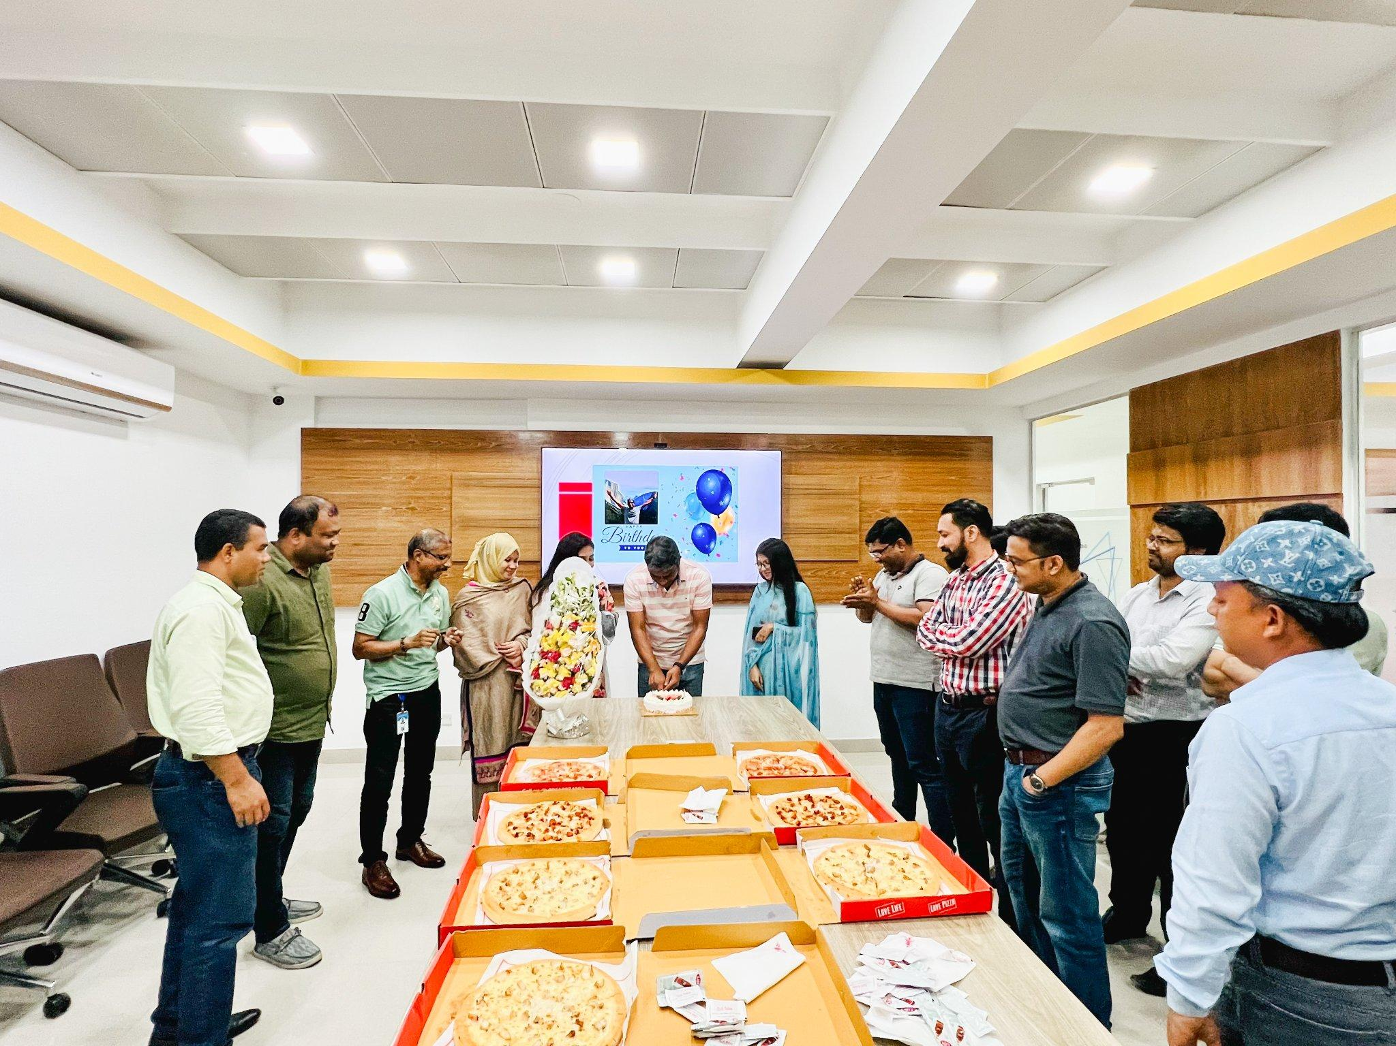
Figure 11: Birthday Celebration of Abdullah Vai (Middle)

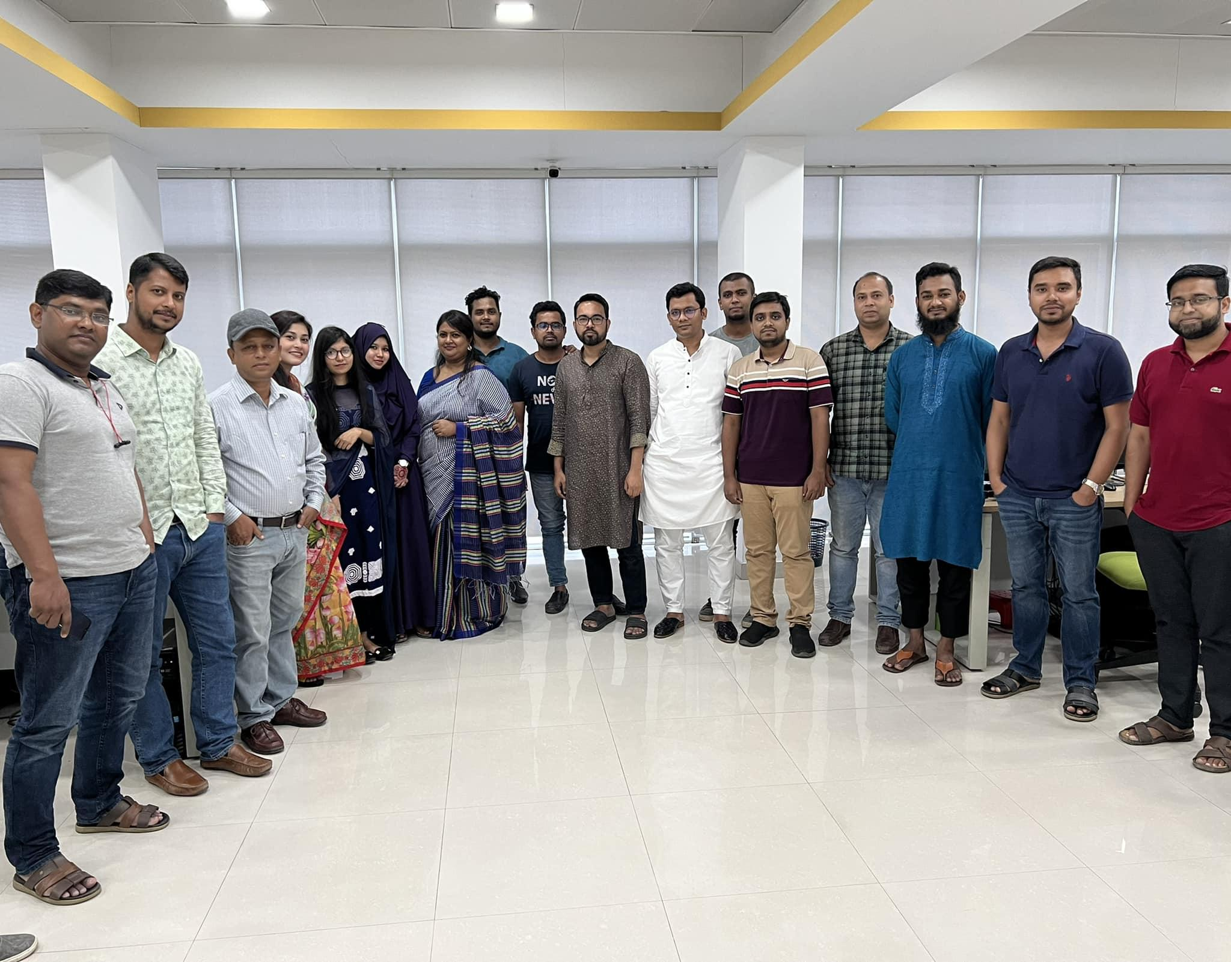
Figure 12: Eid celebration


Figure 13: Genuity 19th anniversary celebration

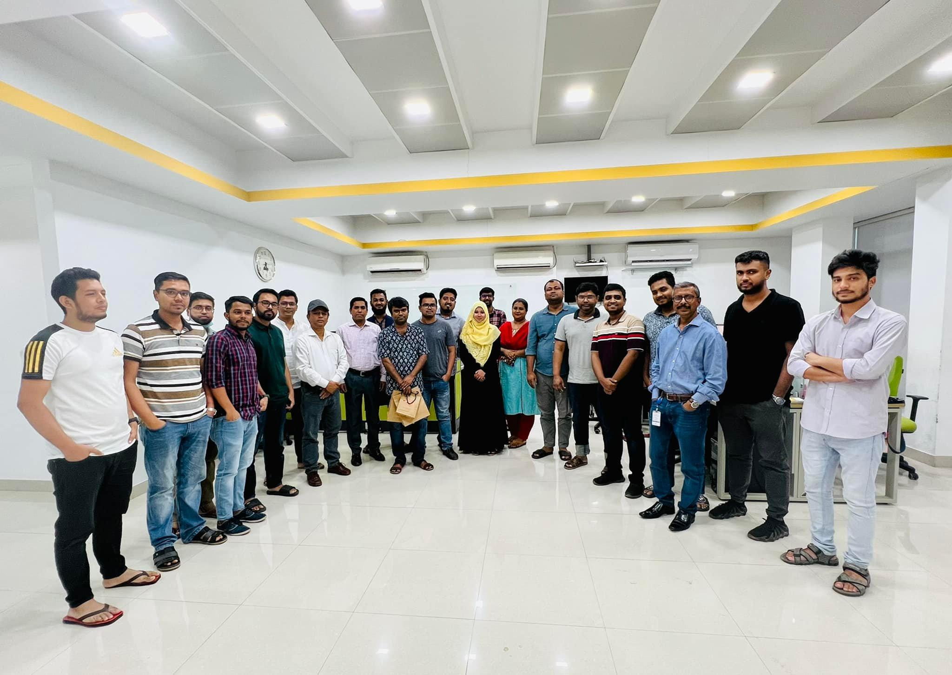
Figure 14: Farewell of an employee

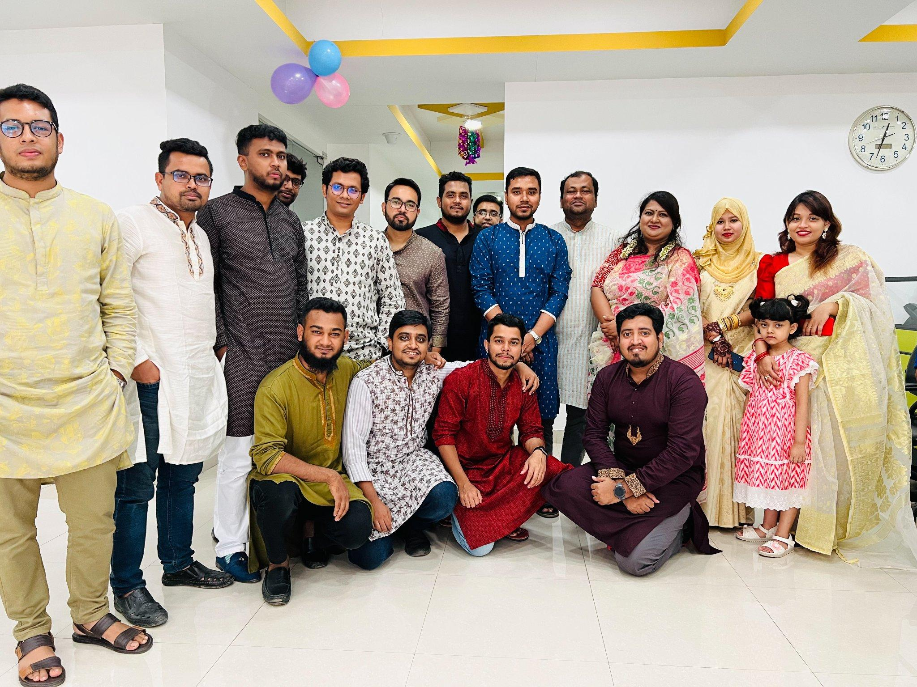
Figure 15: Pohela Boishakh Celebration

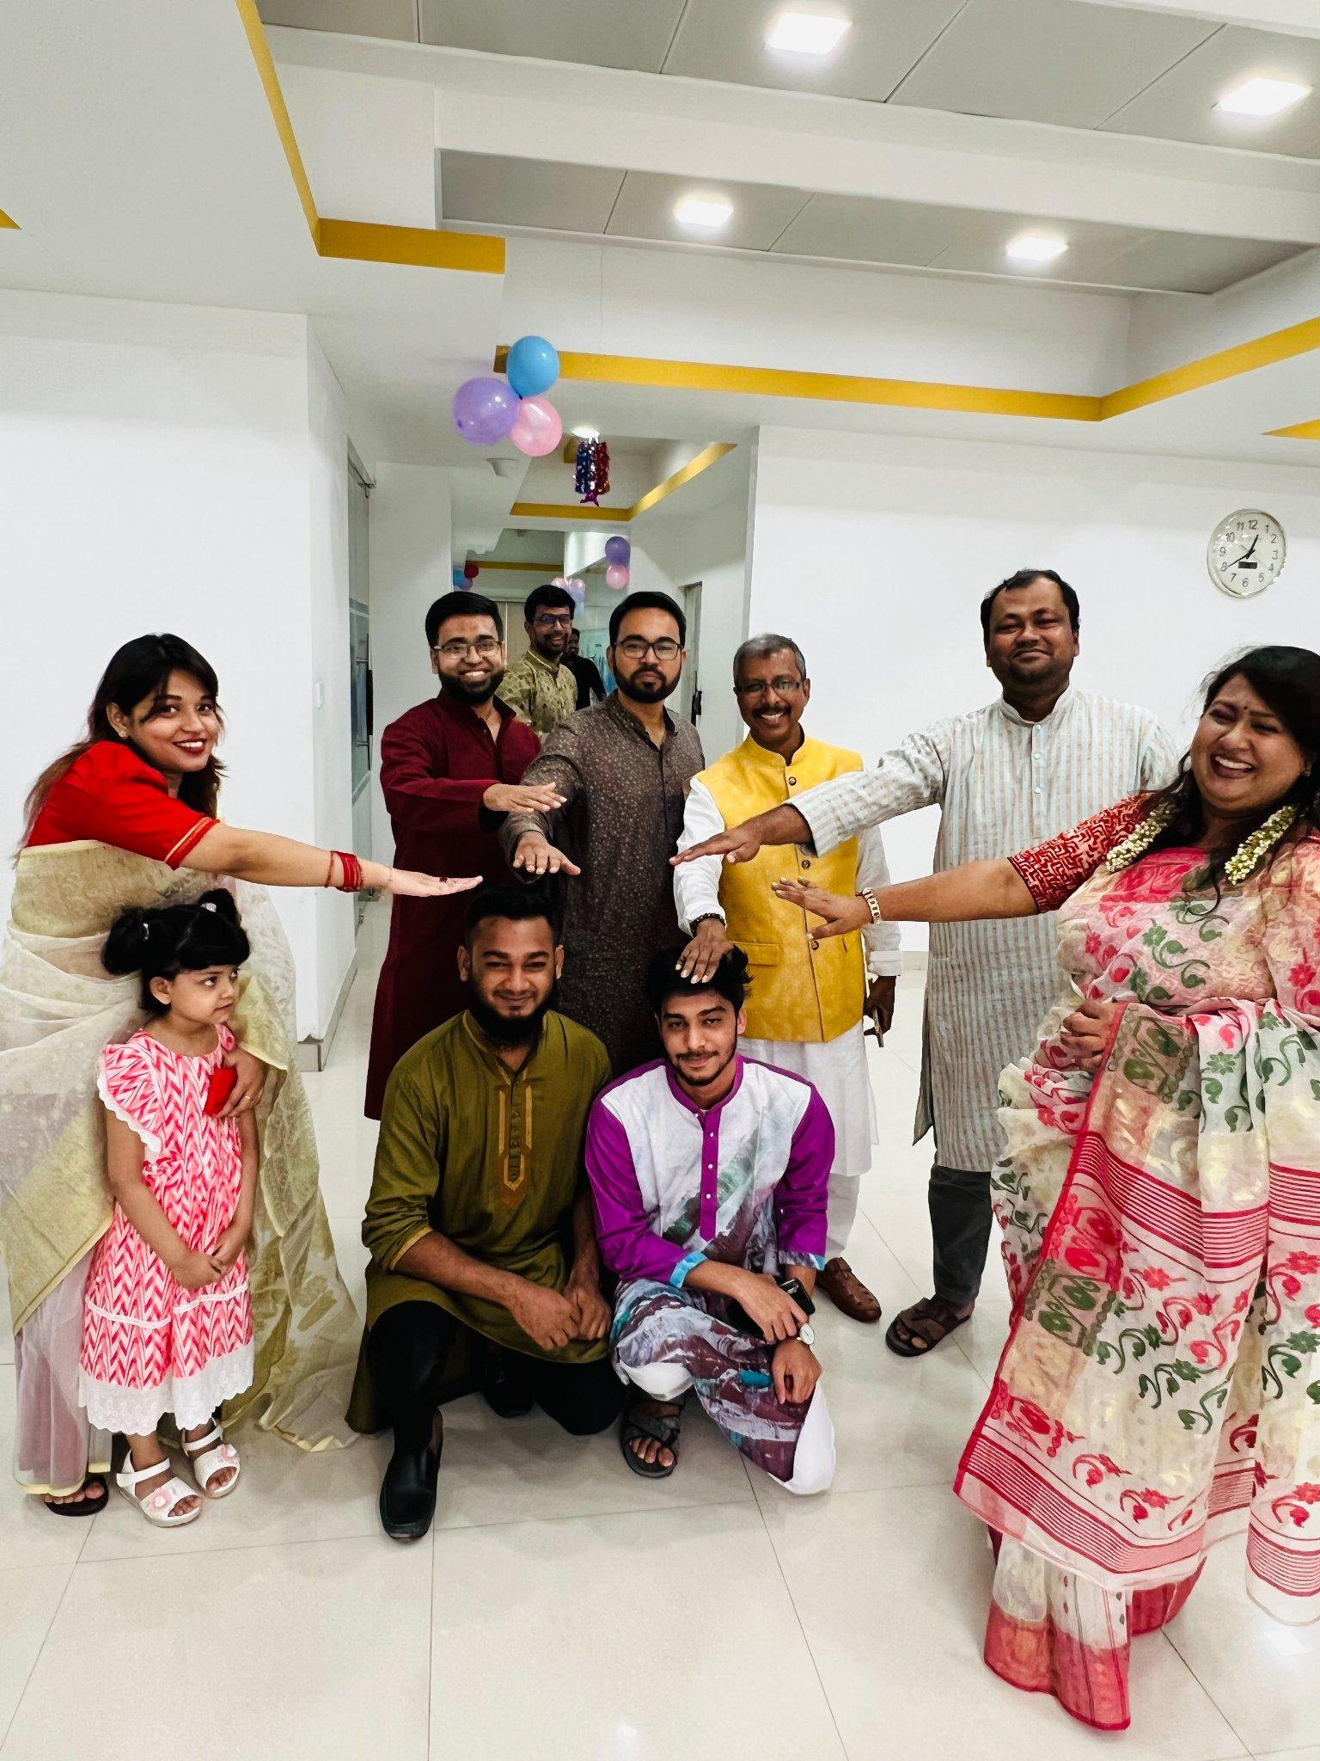
Figure 16: Blessing us to be married in pohela boishakh celebration
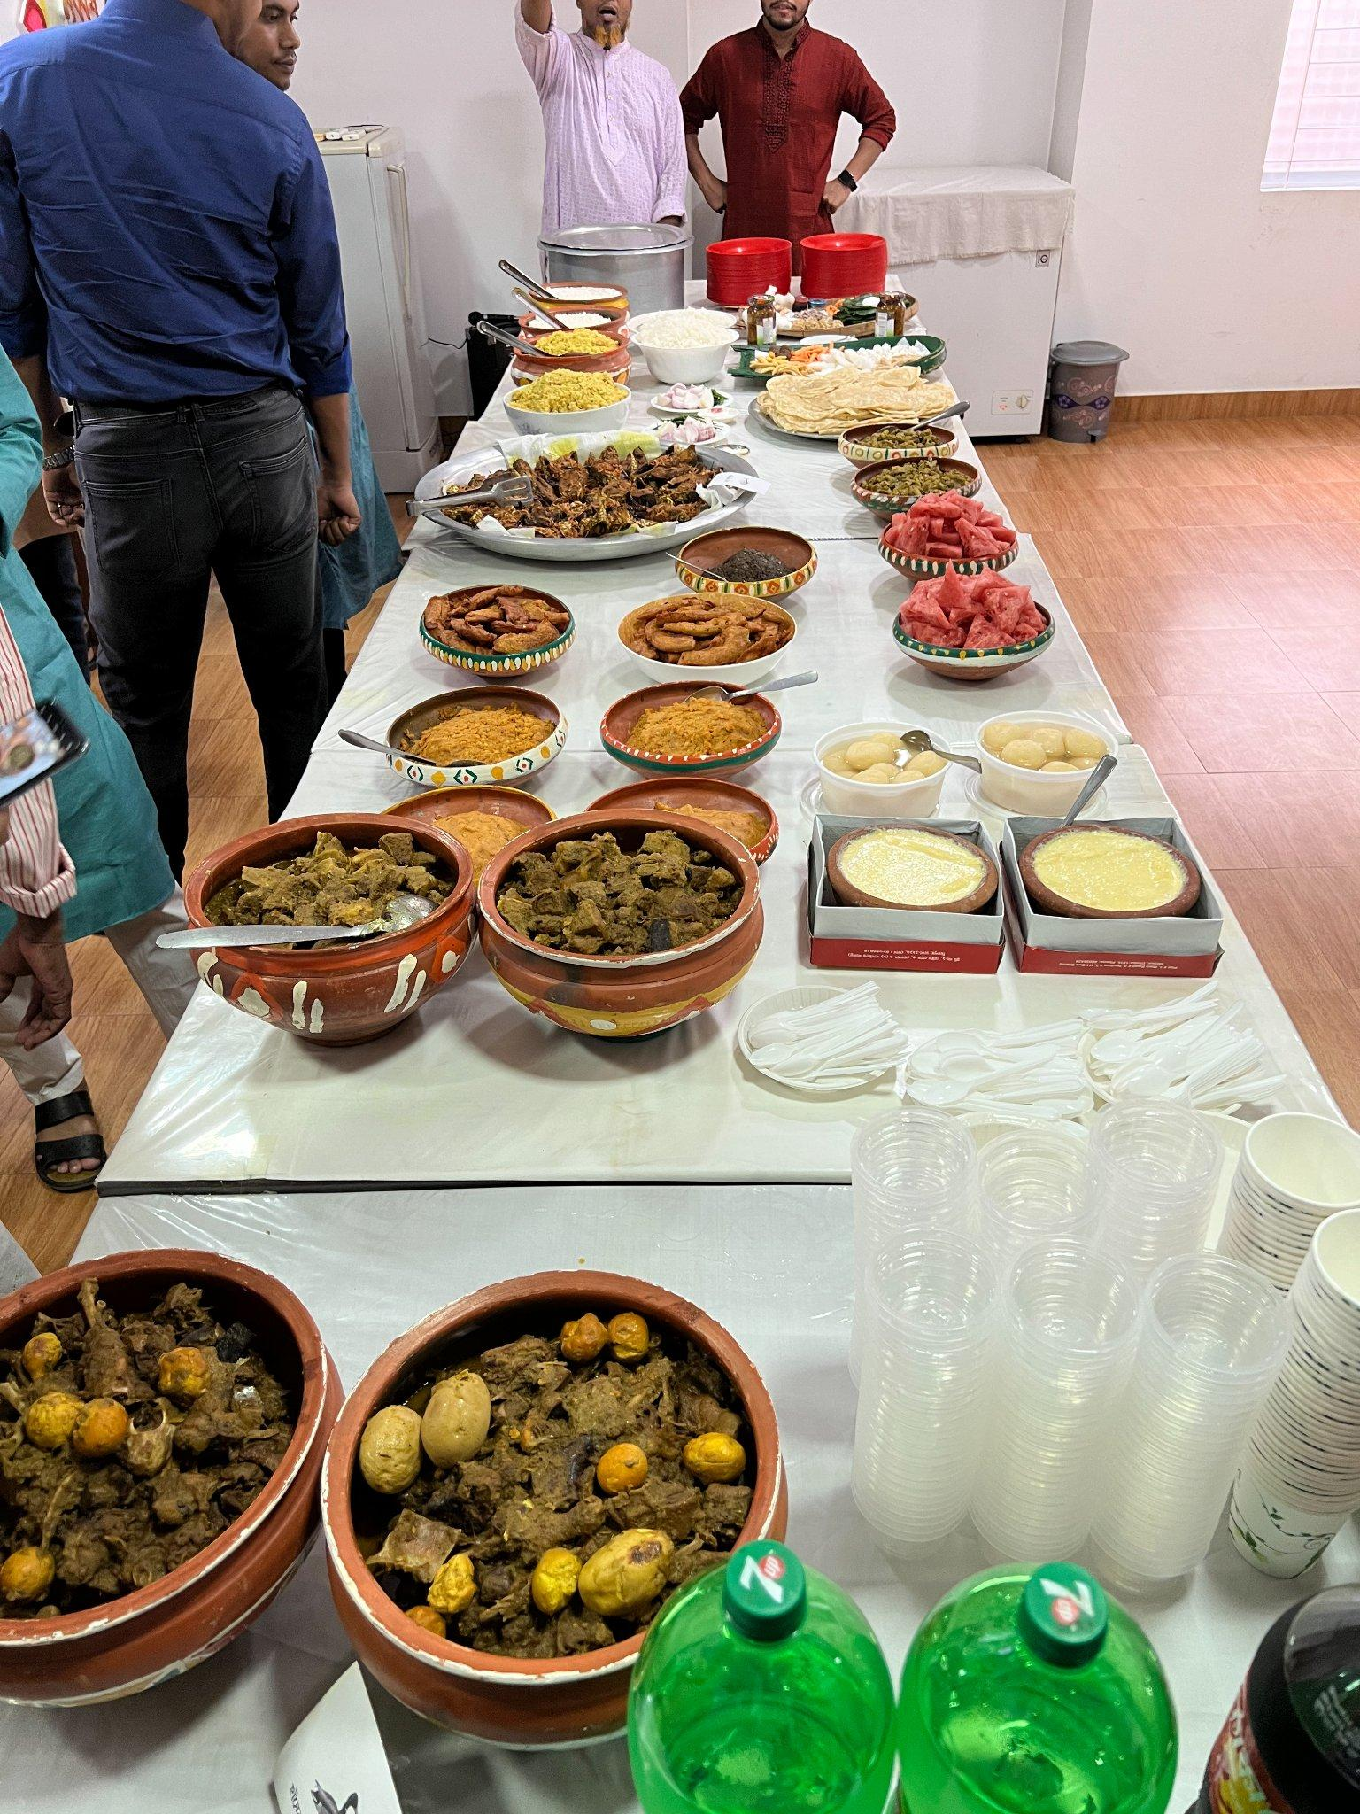
Figure 16: Food provided from the office in Pohela Boishakh Celebration

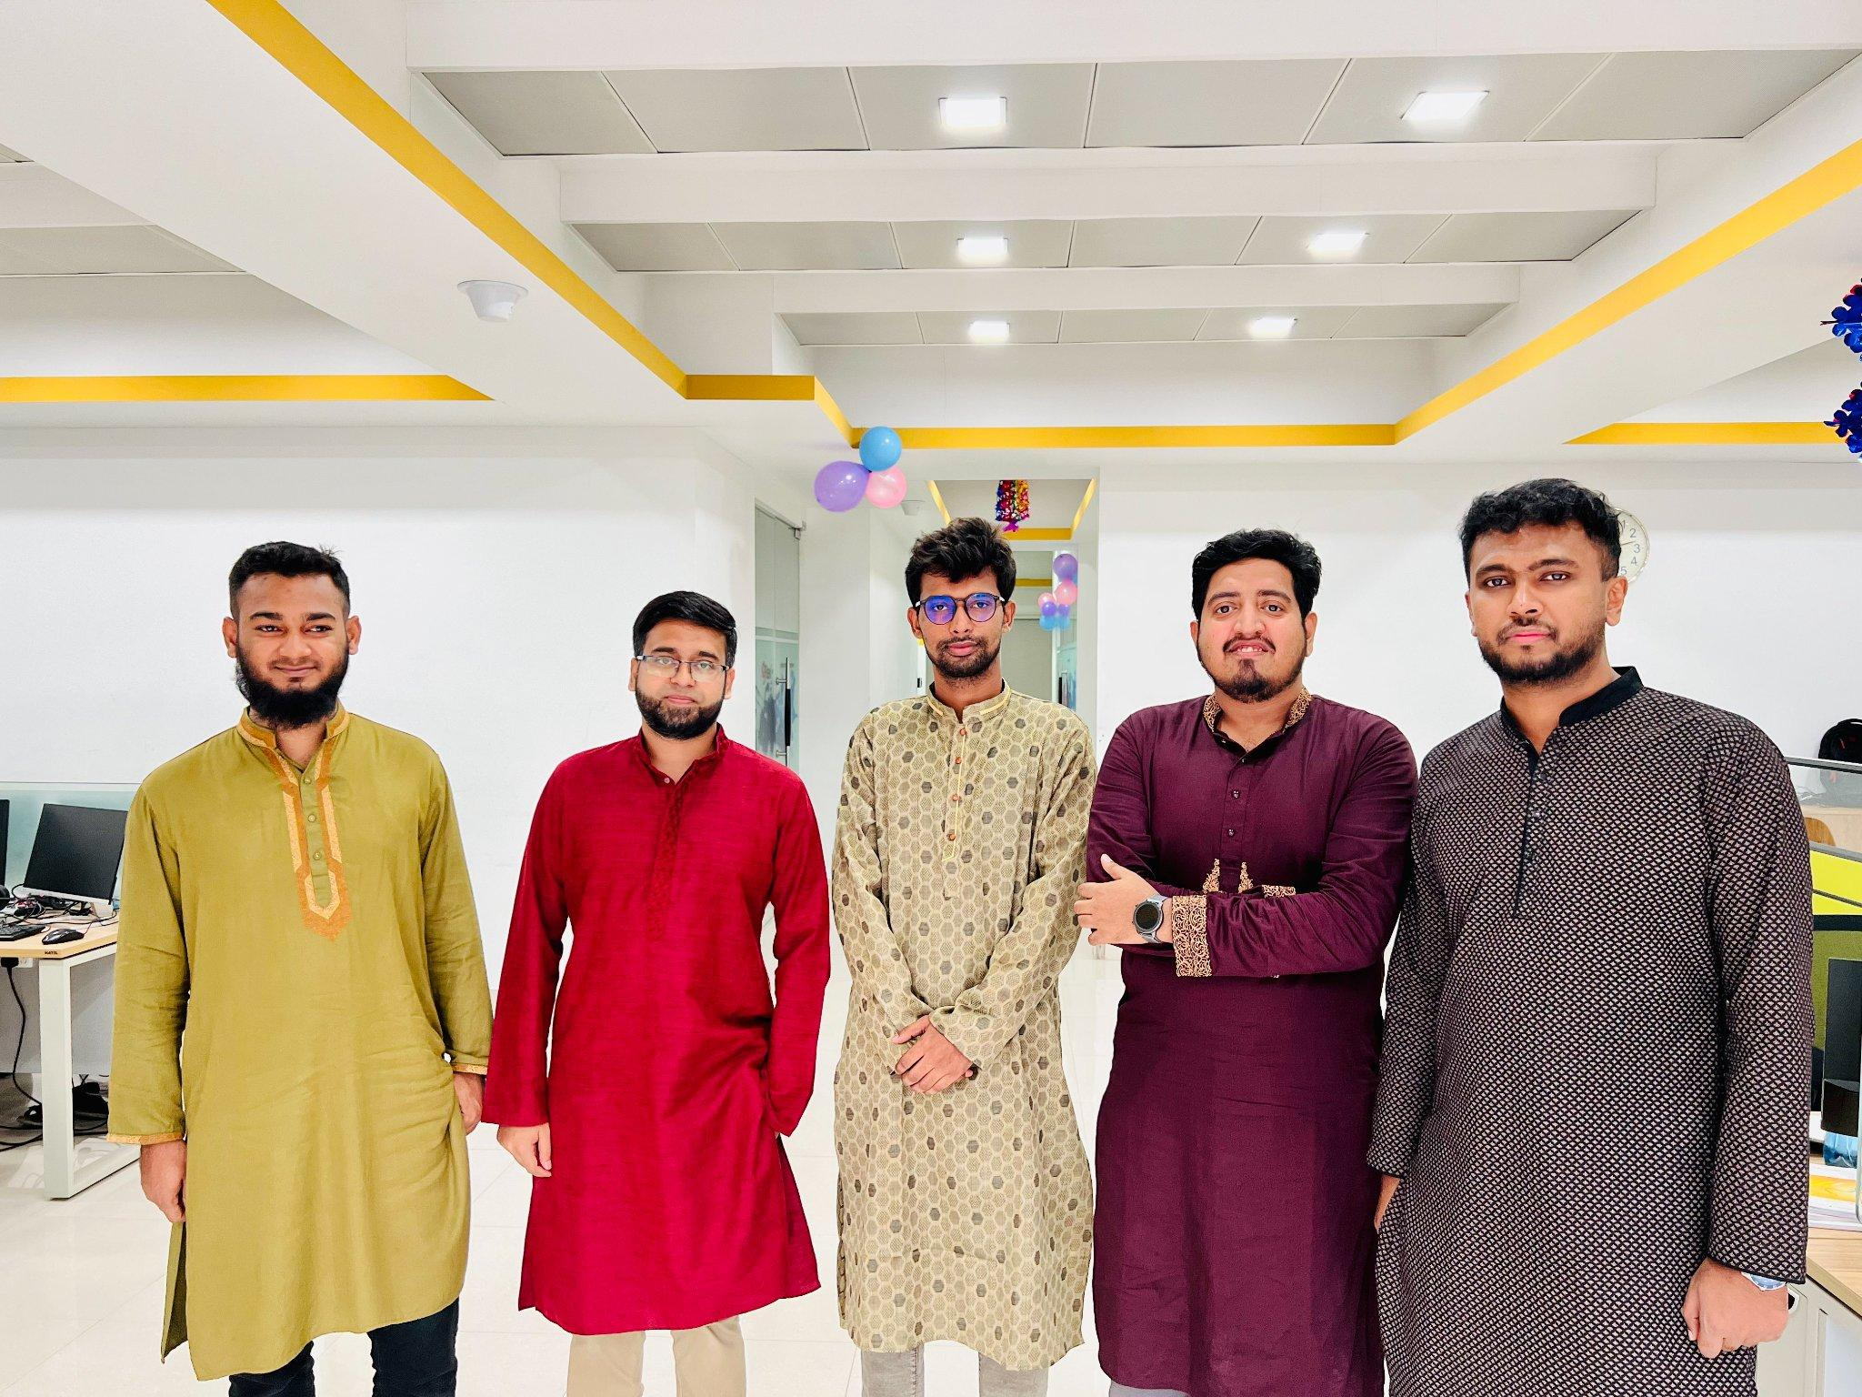
Figure 17: Machine Learning Team in Pohela Boishakh

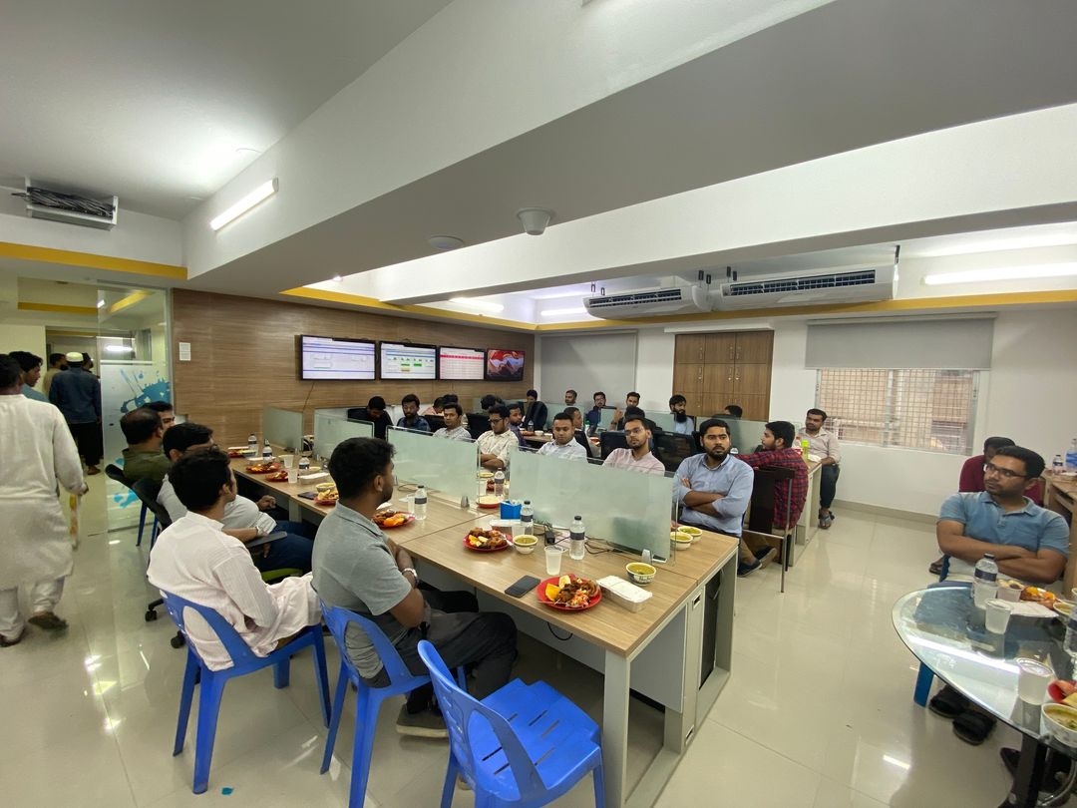
Figure 18: Iftar Party

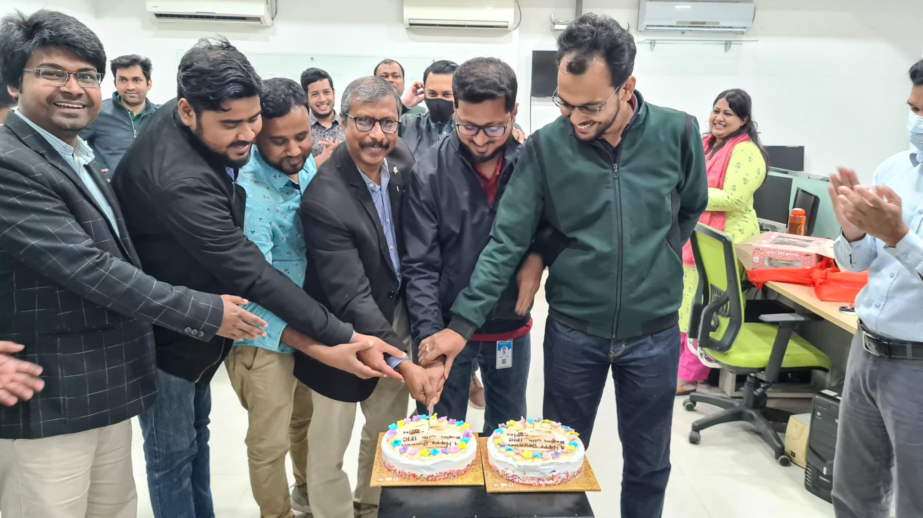
Figure 19: Journey Begins with IFIC Bank

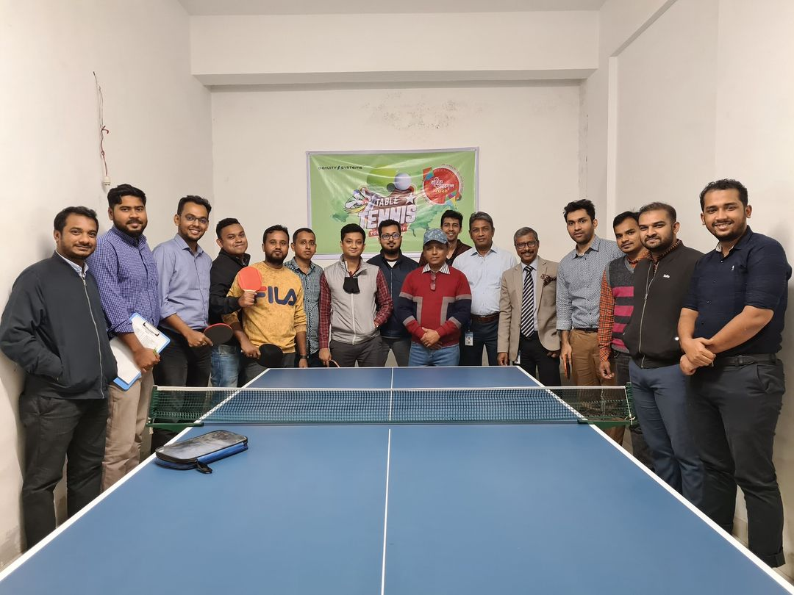
Figure 20: Table Tennis Championship

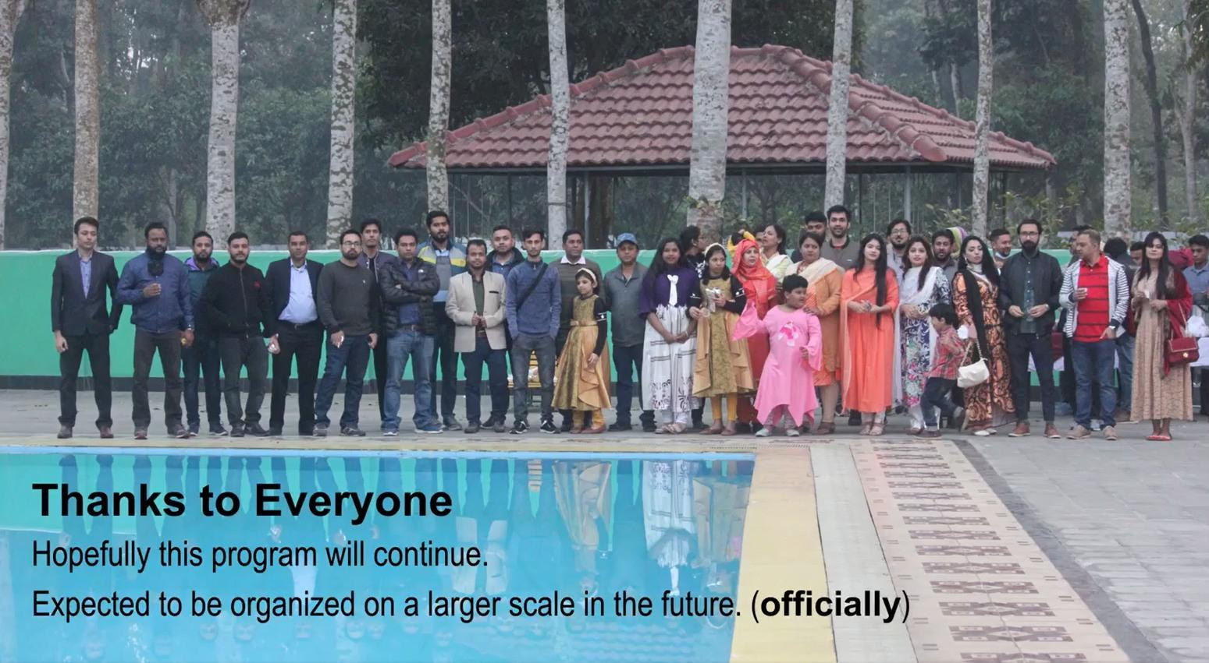
Figure 21: Annual Picnic

2.11. Office Schedule
Office starts at 9:00 am and ends at 6:00 am, from Sunday to Thursday. There is a 1.00-hour break from 12.01 pm for lunch and prayers and 15 min break for tea..

2.12. Facilities for Employees
According to the two-factor theory of job satisfaction, salary is just a hygiene factor. Motivation factors are important for high productivity. Genuity Systems Ltd. has several facilities for the employees.

2.12.1. Domestic Environment
Genuity is like one big family. All the current and ex-employees are members of this Genuity family. Work is fun here. Employees consider the company to be their own responsibility.

2.12.2. Lunch and snacks
The employees are provided with lunch from the office. Weekly 5 days they provide different tastes of food and unlimited tea. And also every department randomly chooses a food manager from the employees for 1 month. Office Provide the manager 5 thousand taka for all employees of the department and he expenses the money for them. So the manager tries to provide snacks all time like biscuits, Chanachur, Coffee, Chips, Seasonal Fruits, and sometimes ice cream

2.12.3. Comfortable Sitting Arrangement
As developers work for hours sitting on the same chair and looking at their desktops, Genuity provides comfortable chairs which are adjustable to their height and arms.

2.12.4 Dinning and Prayer Room
Dining room and the prayer room are located on the 3rd floor of the office.

2.12.5. Games
Actually in Genuity Systems Ltd. there are only Table tennis Games Facilities.

Chapter 3: Internship Details

3.1 Joining Letter

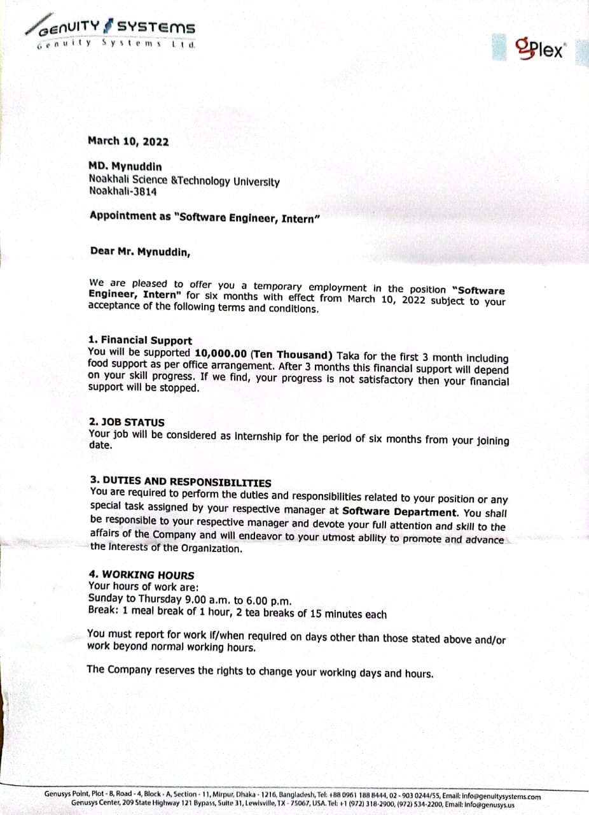
Figure 22: Joining Letter

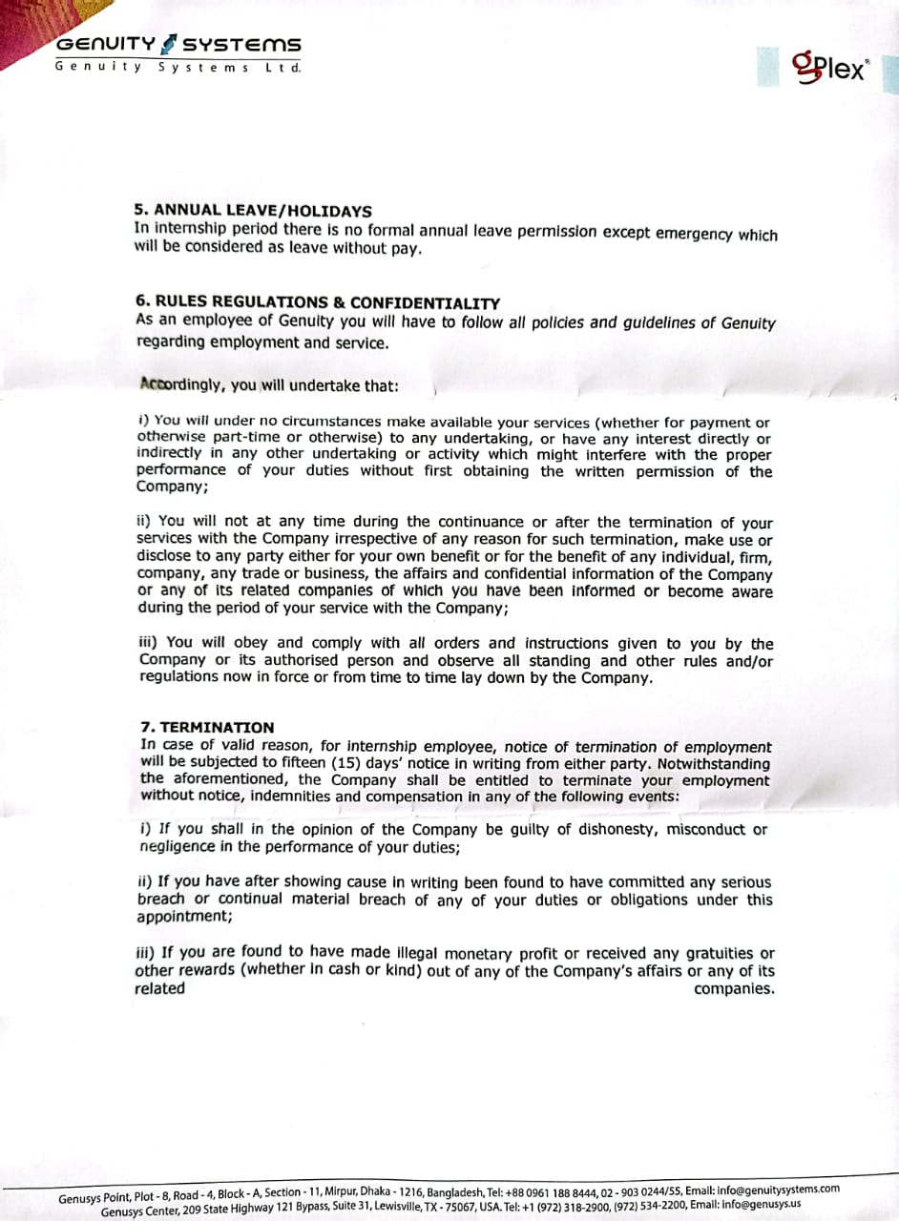
Figure 23: Joining Letter
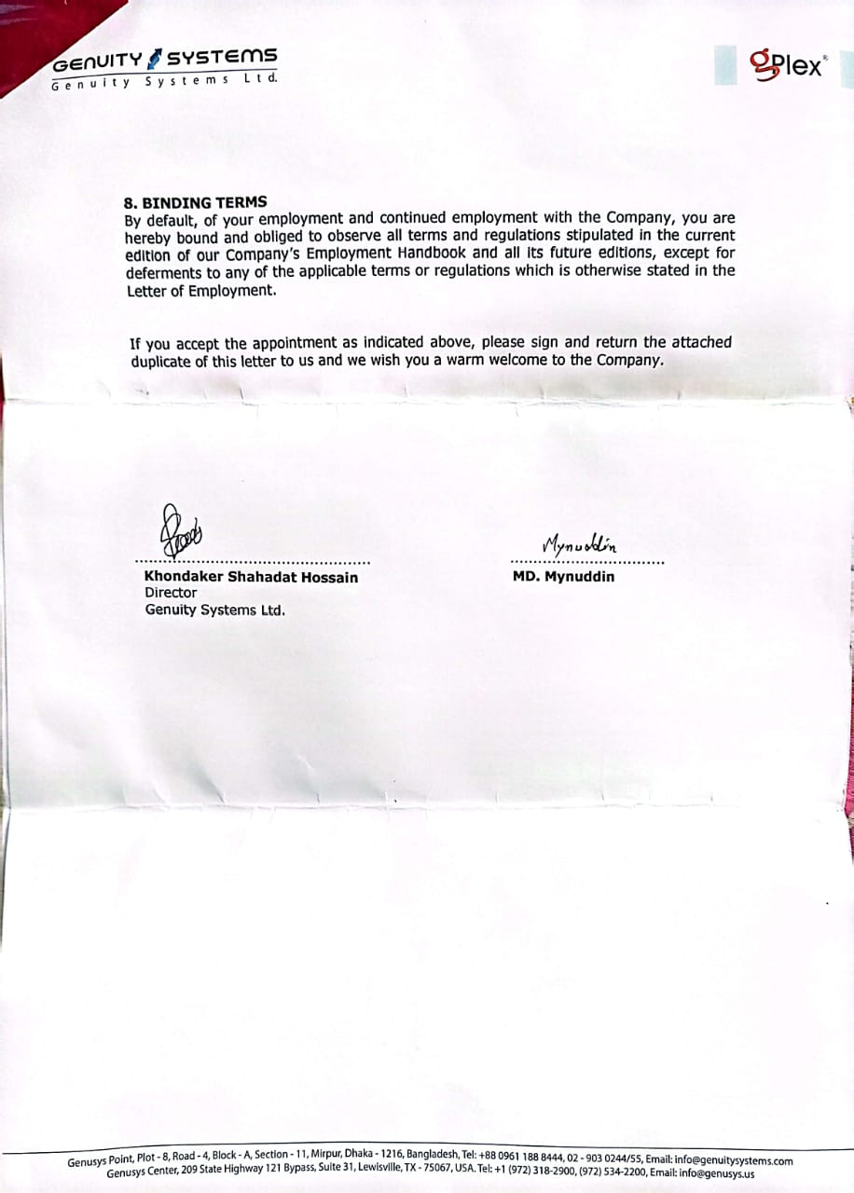
Figure 24: Joining Letter

3.2. Assigned Team

Working Team
Machine Learning Team
Name | Responsibility
Team Leader | Nafees Mahbub  Software Engineer  Genuity Systems Ltd.
Team member | Emrul Hasan Zawad  Software Engineer  Genuity Systems Ltd.
Team member | Rifat Hasan  Software Engineer  Genuity Systems Ltd.
Team member | Azizul Hakim  Software Engineer  Genuity Systems Ltd.
Team member | Md Mynuddin  Software Engineer Trainee  Genuity Systems Ltd.

3.3. First day at office
When I got my joining date, I was extremely glad, yet as the date came closer, I was somewhat apprehensive. Numerous inquiries involved my cerebrum like in what manner will be the air of the workplace, will I have the capacity to modify with the associates, will I have the capacity to function admirably and completer targets, and so on. I came in at about 9:00 am on the first day and my boss welcomed me warmly and introduced me to my team, Managing Director,

and other employees. He showed me where my desk was and told me that he and my team leader would help me get started. He was very helpful and I sat next to him for the morning and just watched what he did. At lunch, my boss and the staff of the office invited me to lunch. I was so nervous; I could hardly eat a thing! We were gone for about 1-1.5 hours and just talked about the company, my studies, etc. After lunch, my team leader took me on a tour of our floor. Introduced me to everyone, showed prayer place, and all that good stuff, and me where the kitchen was, how the coffee machine worked, and where the copy machine was. I had some time to myself to figure out the new computer system and just look around. My day ended at 6.00 pm. It was a great first day.

3.4. Technical Skill I learn
As I join the Machine learning team and if I wanna work on a real-life project I need to achieve many skills. So my team leader provides me with the necessary resources and I follow his instruction. Below I mentioned the list of my learning topics.

3.4.1. Python
- Basic python
- Data Structure
- File handling
- Function
- Module
- Array and String
- Working with Image
- OOP Concept
- Special Variable
- Advanced Function
- Comprehension
- Numpy
- Pandas
- Exploratory Data Analysis( EDA)

3.4.2. Statistics
Basics Stats | Intermediate Stats | Advanced Stats
Introduction to basic terms | Standard Normal Distribution *** | Q-Q plot
Variables | Z score *** | Chebyshev’s inequality
Random Variables | Probability Density Function *** | Discrete And Continuous Distribution
Population, Sample,Population Mean | Cumulative distribution function | Bernoulli And Binomial Distribution
Sample Mean | Hypothesis Testing *** | Log Normal Distribution ***
Population Distribution, Sample Distribution and Sampling Distribution | Many different plotting graphs | Power Law Distribution
Mean, Median,Mode , Range | Kernel Density Estimation | Box-Cox Transform
Measure Of Dispersion | Central Limit Theorem *** | Poisson Distribution
Variance | Skewness of Data | Application Of Non Gaussian Distribution ***
Standard Deviation | Covariance *** | Application Of Non Gaussian Distribution ***
Gaussian/Normal Distribution *** | Pearson Correlation Coefficient *** | Application Of Non Gaussian Distribution ***
Gaussian/Normal Distribution *** | Spearman Rank Correlation Coefficient *** | Application Of Non Gaussian Distribution ***
Gaussian/Normal Distribution *** | Importance of Correlation *** | Application Of Non Gaussian Distribution ***
Gaussian/Normal Distribution *** | All Hypothesis Testing *** | Application Of Non Gaussian Distribution ***
Gaussian/Normal Distribution *** | R-Squared vs. Adjusted R-Squared: What's the Difference? | Application Of Non Gaussian Distribution ***

3.4.3. Data Visualization
- Matplotlib
- Seaborn

3.4.4 Machine Learning

3.4.4.1 Data Preprocessing
- EDA
- Feature Engineering
- Feature Selection
- Feature Transformation
- Dimensionality Reduction
- Handle Imbalance Dataset
- Cross Validation
- Correlation
- Multicollinearity

3.4.4.2 Supervised Machine learning
- Linear Regression for single variable
- Linear Regression for Multiple variable
- Polynomial Regression
- Ridge and Lasso Regression
- Logistic Regression
- SVM(Support vector machine)
- Decision Tree
- Naive Bayes
- KNN(K-Nearest Neighbour)
- Ensemble Technique
  - Bagging
    - Random Forest

  - Boosting
    - Gradient Boosting
    - XGBoosting
    - AdaBoosting

3.4.4.3 Unsupervised Machine Learning
- Clustering
  - Hierarchical Clustering
  - K-means Clustering
  - DBSCAN
I study all these algorithms in-depth theory with implementation and create a report. Here is a sample of a report.

Problem statement: Emotion Detection for Bangla dataset.
Dataset description: we need to detect the emotion of the text, is it normal text or angry text? In this dataset, there are two feature

1.text_bangla : bangla text
2.audio_emotion : emotion of the text .(A-Angry text , N-Normal text)

text_bangla | audio_emotion
এজেন্ট আউটলেটে গিয়েছিলেন | A
আচ্ছা ম্যাম আপনি তো অফারটি সম্পর্কে জানতে চাচ্ছিলেন আমি চেক করে দেখে আপনাকে জানিয়ে দিচ্ছি ম্যাম কিছুটা | A
এখান থেকে আমরা আপনার কোনো বাইক লোন দেখতে পাচ্ছি না এই ফোন নাম্বারের অ্যাগেইন্সটে এই ফোন নাম্বারের অ্যাগেইন্সটে | A
আপনাদের মিসটেকের কারণে হু ইজ নাউ আনফরচুনেট আমি আমার দুর্ভাগ্য এটা | A
স্যার আপনাকে তো অথরাইজ নাম্বার থেকে কল করতে হবে আদারওয়াইজ তো আমরা এখান থেকে | A
স্যার বর্তমানে আমি আমাদের ইন্ড থেকে দেখতে পাচ্ছি আপনার নাম্বারটিতে | N
স্টার জিরো হ্যাশ ডায়াল করে কম্বো বান্ডেল থেকে সেখানে থেকে নিতে পারবেন | N
আচ্ছা স্যার বুঝতে পেরেছি স্যার এ রকম কোনো কল এখন থেকে রিসিভ করবেন না তাহলে অসুবিধাগুলো হবে না আপনার | N
একটু সময় দিন আপনার এরিয়াতে নেটওয়ার্কজনিত কোনো সমস্যা আছে কিনা সেটি চেক করে আপনাকে জানাচ্ছি ঠিক আছে | N
ধন্যবাদ স্যার আপনার মূল্যবান সময় দিয়ে আমাকে সহযোগিতা করার জন্য | N

Solution : Here I need to build a model, where users provide input and the model detects the emotion of the text.like,

Input : আমার সিম এ এতো বেশি টাকা কাটে কেন?
Output : Angry
Input : স্টার এইট ত্রিপল ফোর হ্যাঁশ
Output : Normal
I apply different algorithms and try to find the best one which provides me the best output. Here is the report for each algorithm.

1.Naive Bayes Algorithm

Classification Report
 | precision | recall | f1-score | support
0 | 0.57 | 0.77 | 0.65 | 22
1 | 0.75 | 0.54 | 0.63 | 28
accuracy |  |  | 0.64 | 50
macro avg | 0.66 | 0.65 | 0.64 | 50
weight avg | 0.67 | 0.64 | 0.64 | 50

Confusion Matrix
TP = 17 | FP = 5
FN = 13 | TN = 15

Accuracy : 64.0%

2.K-Nearest Neighbour
Classification Report
 | precision | recall | f1-score | support
0 | 0.54 | 0.86 | 0.67 | 22
1 | 0.80 | 0.43 | 0.56 | 28
accuracy |  |  | 0.62 | 50
macro avg | 0.67 | 0.65 | 0.61 | 50
weight avg | 0.69 | 0.62 | 0.61 | 50

Confusion Matrix
TP = 19 | FP = 3
FN = 16 | TN = 12

Accuracy : 62.0%
Using hyperparameter tuning (for K-neighbour = 1)

3.1.SVM(using default parameter)

Classification Report
 | precision | recall | f1-score | support
0 | 0.54 | 0.86 | 0.67 | 22
1 | 0.80 | 0.43 | 0.56 | 28
accuracy |  |  | 0.62 | 50
macro avg | 0.67 | 0.65 | 0.61 | 50
weight avg | 0.69 | 0.62 | 0.61 | 50

Confusion Matrix
TP = 19 | FP = 3
FN = 16 | TN = 12

Accuracy: 62.0%

3.4.5. Audio signal processing for machine learning

- Overview of Audio Signal Processing
- Sound and waveforms
- Intensity, Loudness and Timbre
- Understand Audio Signal
- Types of Audio Features
- How to Extract Audio Feature
- Time Domain Feature
- Fourier Transform
- Defining the Fourier Transform using Complex numbers
- Discrete Fourier Transform
- Short Time Fourier Transform
- Mel Spectrograms
- MFCCs

3.4.6. Bash Script
- How to build bash script
- Variable and shell expansion
- How to bash process Command line
- Request user input
- Logic
- Processing options and Reading files
- Array and for loops
- Debugging
- Scheduling and Automation
- Working on remote servers

3.4.7. Neural Networks
- Perceptron (Single layer Neural Network)
- Multilayer Neural Network

- Forward Propagation
- Backward Propagation

- ANN - Artificial Neural Network
- RNN - Recurrent Neural Network
- CNN - Convolutional Neural Network

- Activation Function
- Sigmoid
- ReLU
- Leaky ReLU
- ELU
- Swish
- Softmax
- Softplus
- Optimizer
- Gradient Descent
- Stochastic Gradient Descent
- SGD with momentum
- Adagrade
- Adadelta and RMSProp
- Adam
- Loss Function
- Probabilistic Loss / Classification Loss
  - Binary Cross Entropy
  - Categorical Cross Entropy
  - Sparse Categorical Cross Entropy
- Regression Loss
  - Mean Squared Error
  - Mean Absolute Error
  - Huber Loss
- Library: Mainly Keras, TensorFlow, Scikit-learn.

3.4.8. OpenCV
- How to Read, Write, and Show Images in OpenCV
- How to Read, Write, and Show Videos from Camera
- Draw geometric shapes on images
- String Camera Parameters
- Show Date and Time on Videos
- Handle Mouse Event
- Cv.split_merge_resize_add_addWeighted
- Bitwise Operations(AND, OR, NOT)
- How to Bind Trackbar
- Object Detection and Object Tracking Using HVS Color Space
- Simple Image Enhancement
- Matplotlib with OpenCV
- Morphological Transformations
- Smoothing Images |Blurring Images
- Image Gradients and Edge Detection
- Image Pyramids
- Image Blending
- Find and Draw Contours
- Motion Detection and Tracking Using Opencv Contours
- Detect Simple Geometric Shapes
- Image Histograms
- Template matching
- Hough Line Transform
- Road Lane Line Detection
- Haar Cascade Classifiers
- Detect Corners
- Background Subtraction
- Resource
- Warp Perspective
- K_Face and Eye Detection From Videos
- K_HAAR cascades Classifier
- K_Pedestrain Detection
- Basic Image Manipulation
- Image Annotation
- Image Enhancement
- HDR
- Panorama
- Face detection
- Edge Detection

3.5. Assigned Project
Actually I was not assigned to any projects. There is a project “Face Recognition” who is responsible for this project he left the job without completing this. The team leader assigned me to this project.

3.5.1 Face Recognition
A facial recognition system is a technology capable of matching a human face from a digital image or a video frame against a database of faces, typically employed to authenticate users through ID verification services, and works by pinpointing and measuring facial features from a given image.
The team leader has given me the task that the system “recognizes multi-face with good FPS”.

3.5.1.1 Project Screen Shoot

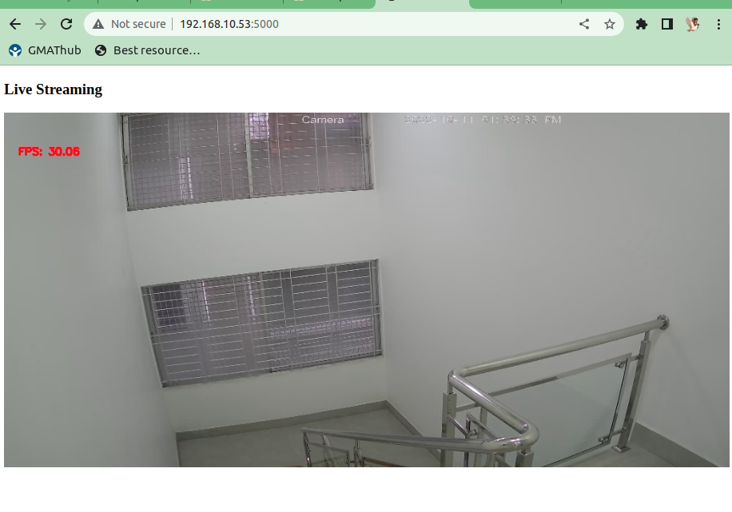
Figure 25: Office camera for face recognition

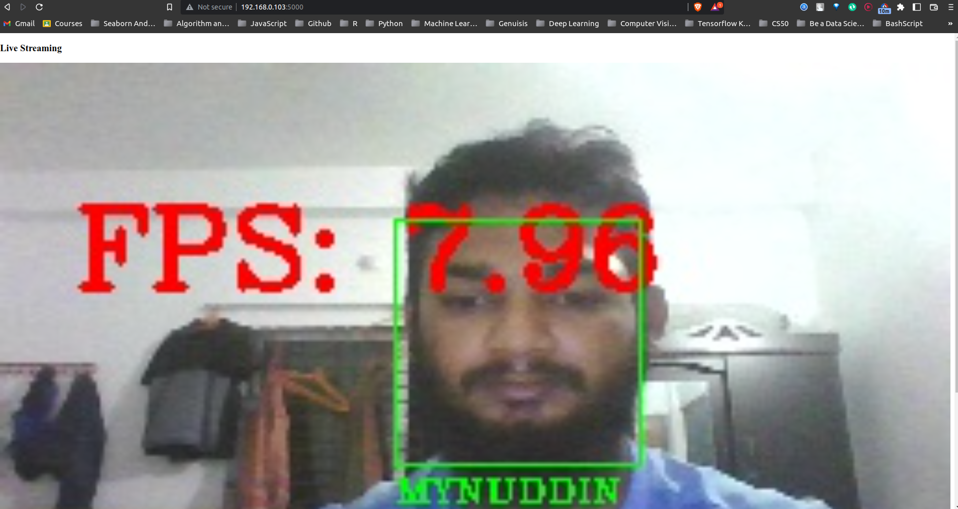
Figure 26: Face recognition for single face
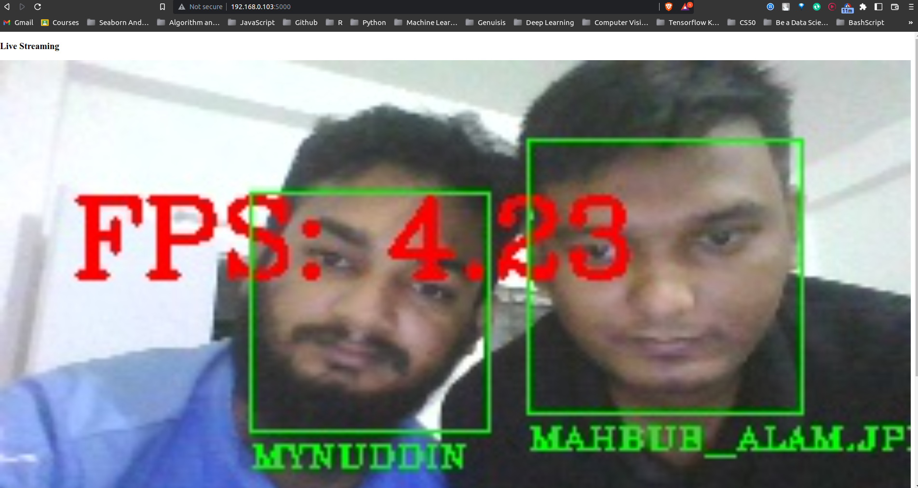
Figure 27: Face recognition for multi-face

As far as I complete every task given by my team leader, I also completed this task on time.

3.5.1.2 Tools and Technology I used
- Python
- Dlib
- Mediapipe
- Face recognition
- Flask
- VideoStream
- CV2
- Visual Studio Code
Last few days of my internship team leader introduced to me Kaldi ASR (Automated Speech Recognition) for speech to text and Coqui TTS for text to speech.
3.7. Technical or skill-based lacking and challenges
- Working with Bangla dataset
- OpenCV
- Linear Algebra
- Neural Network
- Statistic
- Probability
- Calculus

Chapter 4: Self Assessment

4.1. Punctuality
Punctuality is the act of completing something on time, coming to work on time, and meeting deadlines. It shows that I respect other people’s time and am willing to be organized. It’s an essential skill in both personal and professional settings. Being punctual shows that a person is reliable, organized, and respects other people’s time. In order to meet the company’s requirements, employees are expected to be punctual.

In Genuity Systems ltd. office starts at 9.00 AM and closed at 6.00 PM. I was always punctual. I enter the office on time. There is an Employee Management System that traces everything about the employee. If an employee enters the office before 9.15 AM EMS shows you a green signal. I always maintained the company rules. Meeting deadlines is an important punctuality skill because it shows that I am organized and can manage my time well. I always meet deadlines. When I meet deadlines, it shows that I am reliable and can be trusted to do work on time. And also I was always respecting other’s time and trying to be Organized because it helps me keep track of my time, tasks, and resources.

4.2. Attitude
Throughout my whole journey as an intern, I was always enthusiastic to learn something new. At first, I was also a little bit afraid of the new environment of the company. But, within a short period of time, I made myself accustomed to it. Although it is always difficult and challenging to learn new things I think that I was able to cope with these challenges. My rational, hard-working, and passionate attitude and my supervisor's guidelines helped me to deal with the new corporate culture, office environment, and new technology. I hope that this attitude will help me to handle any critical situation easily in the days coming.

4.3. Ability to learn
Changes can make humans either immortal or ordinary. In my case, there occurred a radical change in me too. Somehow, I have got the power of learning to work exceptionally well.

Genuity made me introduced to this. At Genuity, I have got very nice and friendly mentors and supervisors who taught me really well. Actually, I never meet anyone like some of my team members and my mentors. They were never annoyed to answer even my stupid questions. And at the same time, I could catch everything that they have been telling me. So, I would say, I learned at Genuity really well and I would like to thank my teammates for that. Hence, in my opinion, Genuity is a good place to learn and I have made the best out of it.

4.4. Dependability
The word "Dependability itself bears a lot of gravity. Sometimes it is seen that many companies do not want to involve their interns in their main and core projects. They think that it is too much risky and also time-consuming for them to involve interns because interns come for only three to six months and after that, they will go eventually. In my company, I as well as my other co-intern members initial hard-working convinced our manager very positively. I also hope that this dependable attitude will result in a long-term bridge between IIT and Genuity SystemsLtd.

4.5. Initiative
Initiative is one of the most essential characteristics of any employee. In a company, everybody works in a group and in each group every person has his own responsibilities. There is no culture to push anybody to do their responsibilities. Genuity was like a family. Whenever I have done any work, I tried to do it with my full efforts. When I faced any problem I tried to solve it myself and proceed well on my own. I hope that this sort of attitude of mine will help me in the long run.

4.6. Quality of Work
Every company's reputation depends on its products' quality and product quality depends on the quality of work and their doers. So in every project quality must be considered one of the highest priority features. And that's why there are no compromises allowed in the qualities of employees even.

I always tried to maintain my best quality in these projects. There were given lots of training to us for our quality improvement. I have followed standard documentation, structured coding development, and formal reporting according to every day's task list. I maintained project planning and project timeline for completing my project properly. Hence, I always tried to maintain the highest quality of work throughout my internship at Genuity Systems Ltd.

4.7. Relations with Others
The best thing about Genuity is its cordial and cooperative employees who will make your staying a lively and fruitful one. Whenever I faced any problem, I frankly discussed it with my colleagues. They tried to help me at their best. In our free time, we would share everything about ourselves like a family. In our company every employee's birthday party used to be celebrated with birthday party cake. It was really good to work with experienced and talented persons. Moreover, I had a very close relationship with all my colleagues which helped me to be among themselves in their weal and woe.

4.8. Maturity-poise
Though at the beginning I had more confidence in myself, gradually it turned into a sheer one. Working on some real-time big projects helped me quite mature poise and confidence. Involvement in these projects also taught me how to handle and cope up with big projects, how to manage everything easily, and how to maintain project timelines and schedules. My maturity and poise also helped my manager to easily involve me in such critical projects. Hence, I am quite confident and poised nowadays and hope to maintain that throughout my whole life.

4.9. Judgment
Judgment is a mature term to refer to. It is not generated within a day or in a month. It is the quality that builds up gradually with the gathering experience. It helps to take appropriate decisions at the appropriate times which will be helpful for any company to maintain its commitment to clients. As I was involved in a project, I tried to develop my skill on judgment. In

this phase I tried my best to follow the standard way of coding, maintaining the timeline, and planning of doing things at the right time. All these helped me to grow the judgment quality inside me with time and experience.

4.10. Initiative
In a company everybody works in a group and in each group every person has his own responsibilities. I tried to complete all my tasks with my own responsibility, and if I had any problems, then I can go for any type of help needed for that task to the team members. Or even I had completed my work before the given time limitation, with my own responsibility I have done another task. Actually, my works were defined there. It was known to me, that what I have to do on daily basis, and if there were any work that I didn’t know, my supervisor assigned that to me. Working in the Machine learning team has made me more responsible as the quality of the product is totally dependent on the team and it made me able to take initiative for the upcoming tasks.

4.11. Teamwork
Teamwork is the collaborative effort of a group to achieve a common goal or to complete a task in the most effective and efficient way. This concept is seen within the greater framework of a team, which is a group of interdependent individuals who work together towards a common goal. The four key characteristics of a team include a shared goal, interdependence, boundedness and stability, the ability to manage their own work and internal process, and operate in a bigger social system. The basic requirements for effective teamwork are an adequate team size.
In Genuity after meeting with clients team leader assigned the task to the developer and every team member needed to update their task on a daily basis. I am also one of them. Every week there is a team meeting where everyone explains what they do, what the problem is with this task everything. If there is a problem and one of the team members can't solve this then the whole team tries to solve the problem. When I face a problem first I try to solve it by myself. If can't solve it then I knock my supervisor or other team members. Above all, before I join Genuity Systems Ltd. I actually don't know how actually a team should work. What was the

benefit when I worked with the team below I mention the point.
- Improve Developer Skills
- Increase code quality
- Boosts Productivity
- Creativity and Innovation
- Retrospectives Continuously Elevate Efficiency
- Increase Business Potential
- Morale and cohesion keep teams together longer
- Creative idea
- Improve problem-solving skill

4.12. Overall Progress
The six months internship period, has given me a lot of experience and knowledge. With these experiences, I can build my career more successfully in the future. Working on a Machine Learning team has made my analytical mind stronger. Now I am pretty much sure that, I have the capability to work with real-life problems. Involvement in these projects also taught me how to manage everything easily, how to maintain tasks timeline and schedules, and how to develop a system. The journey at Genuity Systems ltd. made me more hardworking, passionate, punctual, responsible, and confident.

Chapter 5: Conclusion

I learned valuable information about the software industry, its culture, working conditions, and all about software development thanks to the internship program. Participating in daily and weekly team meetings with the team leader and other team members and talking about the challenges of the projects gave me the confidence to cultivate a never-give-up mentality. In addition, it motivated me to work hard, be accountable, and self-assured while teaching me about the software life cycle used in the software industry. The thing I want and cherish the most is inspiration. They constantly gave me the motivation and tools I needed to learn new skills and adapt to them. They also gave me advice on what to study and how to approach the learning process.
The internship program has increased my teamwork capabilities as well as my respect for the team mate’s ideas and suggestions. Team discussions like brainstorming sessions helped me identify and solve numerous problem issues which would have been impossible to solve otherwise.
I would like to convey my thanks to IIT, NSTU for providing me with an opportunity to gain an idea of the competitive environment in the professional field. It has certainly lifted my software development skills in terms of planning, designing, coding, and deployment. I now look forward to facing the upcoming challenges of the world.

Chapter 6: References

[1] https://www.genuitysystems.com/index.php “Genuity Systems Ltd.” [Acees 23 October 2022]
[2] https://www.facebook.com/groups/1645869302384991 “Genuity Systems Ltd. Facebook Group” [Acees 23 October 2022]
[3] https://github.com/Mynuddin-dev?tab=repositories “Github” [Acees 23 October 2022]
[4] https://docs.opencv.org/4.x/d6/d00/tutorial_py_root.html “OpenCV Doc” [Acees 23 October 2022]
[5] https://github.com/Mynuddin-dev/Bash-Script “Bash Script Github Repo” [Acees 23 October 2022]

